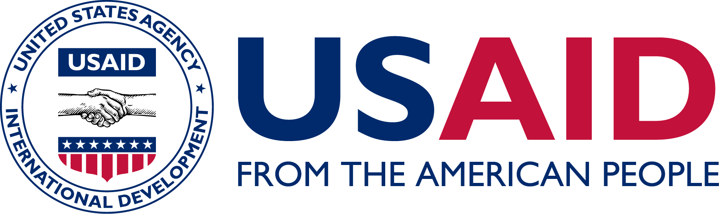
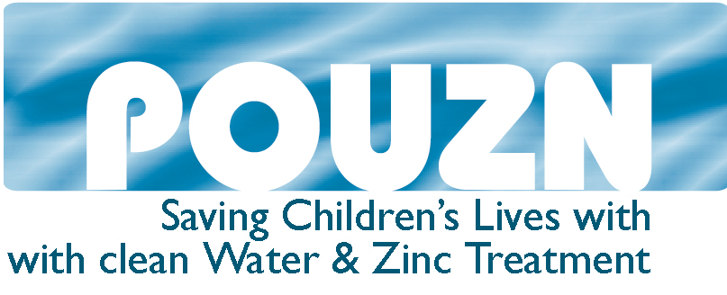

Pediatric Zinc as Treatment for Diarrhea

Every year approximately 1.7 million children die as a result of diarrhea and dehydration. In the majority of cases, this is preventable through exclusive breastfeeding, improved hygiene and sanitation and access to clean water, yet diarrhea is still one of the leading causes of death among children under five.

In May 2004, WHO/UNICEF issued a joint statement recommending the use of zinc, an essential micronutrient for human growth, development and maintenance of the immune system, and a new formulation oral rehydration solution (ORS), with reduced levels of glucose and salt, as a two-pronged approach to improved case management of acute diarrhea in children.

Dispersible zinc tablets, which dissolve easily in a tablespoon of clean water or breastmilk, can be used for zinc supplementation for children aged one to 59 months. WHO and UNICEF recommend 20 mg of zinc per day for ten -14 days for infants and children, ten mg for infants under six months of age.
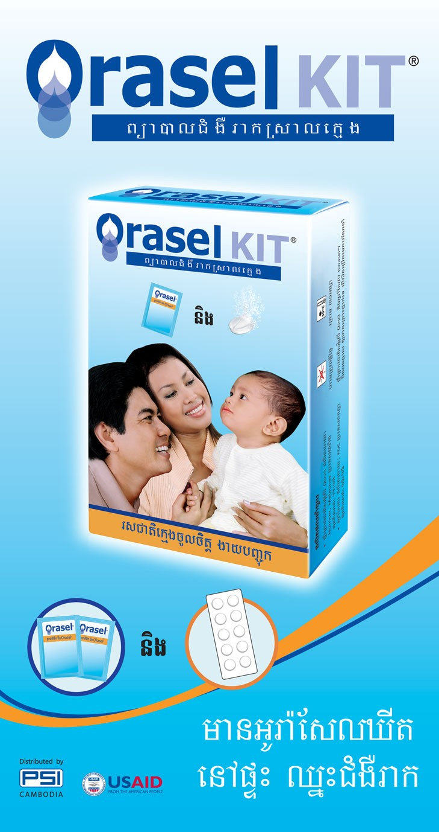

For more than 20 years researchers have been assessing the benefit of zinc supplementation during diarrhea episodes. Studies have shown that zinc supplementation results in a 25% reduction in duration of acute diarrhea and 40% reduction in treatment failure or death in persistent diarrhea. These studies also revealed that children receiving zinc experience a decrease in the severity of their diarrhea episodes. A ten day course has proven to provide a prophylactic protection against future bouts of diarrhea for two to three months after the episode.

The combined recommendation of zinc and ORS is a safe, effective and inexpensive diarrhea treatment for children in the developing world. The only known side effect of zinc use is vomiting, which is rarely reported and is typically attributed to a metallic taste in the zinc. Use of high-quality zinc products easily avert this side effect.

Zinc manufacture requires only simple technology and no expensive ingredients. Zinc can be produced in both syrup and tablet form. Efforts are already underway to transfer the technology from French developer and patent holder, Nutriset/Rodael, to local manufacturers in the developing world, who will be able to take over production, thus keeping costs affordable for the poorest of the poor.

Pilot programs have begun in several countries, testing various approaches to training both health facility staff and community health workers, developing and delivering behavior change communication messages and consumer educational materials, and monitoring program progress. Private sector zinc programs are testing the feasibility of marketing zinc tablets and ORS as stand alone products or packaging them together as a Diarrhea Treatment Kit (DTK).

For more information visit the POUZN (Social Marketing for Diarrheal Disease Prevention and Treatment) website: www.pouzn.com

