Business for Health
Business Skills for Private Medical Practices
_____________________________________________________________________________________________________________________

Participant’s Manual

Module 10: Risk Management in Your Health Practice




Table of Contents

Welcome
3 Agenda and Learning Objectives
4 Introductions

Risk Management Defined
5 Discussion Question
6 Risk Management

Telephone Communication Risks
7 The Need for Telephone Protocols
9 Telephone Protocol
10 Sample Phone Message Form
11 Seven Rules for Medical Office Phone Etiquette

Credentialing Risks

14 First Hand Credentialing
15 Credentialing Risk Factors
16 Sample Credentialing Checklist

Medication Management Risks
18 Medication Management “Six Rights”
20 When Do Errors Occur?
21 Sample Medication and Allergy Record

Privacy and Confidentiality Risks

22 Privacy and Confidentiality

Risk Management

23 Risk Management Case: Dr. Evans Kwendo
27 Risk Management Assessment for Dr. Evans Kwendo

Summary and Evaluation
28 Risk Management and Quality Improvement
29 Next Step
30 My Key Takeaway
31 Evaluation Sheet

Operations Management of Your Practice
Risk Management in Your Health Practice

Agenda:
- Welcome
- Risk Management Defined
- Telephone Communication Risks
- Credentialing Risks
- Medication Management Risks
- Privacy and Confidentiality Risks
- Risk Management
- Summary and Evaluation
- Close

Learning Objectives: During this workshop, you will:

- Define risk management;
- Assess the need for telephone protocols;
- Create a credentialing checklist;
- Review the consequences when the “Six Rights” of medication management are not fulfilled;
- Describe your privacy and confidentiality practices;
- Propose how to handle risk management issues;
- Discuss the relationship between risk management and quality improvement in a health practice;
- Explain the next step; and
- State your key takeaway from this session.
Note: All of the information contained in this manual is drawn from: ”Risk Management 101”: A Practical Program for the Office Practice, by Reid A. Pearlman, J.D., Risk Management Consultant, MAG Mutual Insurance Company.

Introductions

Instructions: Please introduce yourself to the group:

1. Your name
2. Your job title
3. Your business
4. How long you have had your business

Discussion Question

Instructions: Please pop up and stand by your chair if you have an answer to this question:

How does risk management apply
to human resources, medications, medical supplies,
medical records, and facility management?

Risk Management

Risk management in health care considers patient safety, quality assurance and patients’ rights. It is concerned with identifying, evaluating and correcting potential risks that could lead to injury to patients, staff members or visitors, and/or result in property loss or damage.

The potential for risk permeates all aspects of health care, including management, medical mistakes, electronic record keeping, provider organizations and facility management.

Your greatest risk may be a complication that you do not have the capacity, facilities or credentials to deal with.
Risk management can be proactive or reactive. Proactive risk management focuses on avoiding or preventing risk. Reactive risk management focuses on minimizing loss or damage after an adverse/bad event, such as an unexpected death, failure to diagnose or treat disease, surgical mistakes or accidents.
Applying common sense can prevent bad results or accidents. For example, a facility management safety issue is the fact that slippery floors in high traffic areas can cause accidents. Washing floors at low traffic times and diverting traffic away from wet floors until dry is a proactive means of risk avoidance.
Maintaining ethical and legal practices can prevent the risk of a poor reputation or loss of licensure.

Adapted from: The Definition of Risk Management in Health Care eHowhttp://www.ehow.com/about_6619711_definition-risk-management-health-care.html#ixzz2VpceOVyW

The Need for Telephone Protocols

“Telephone protocols” involve phone calls where medical advice is sought, calls are screened and/or advice is rendered. Because of the sporadic and multiple-party nature of this type of communication, serious system failures can and have occurred.

Instructions: Working with your table group, please review the case situation below and answer the questions on the following page.

Case: Telephone Advice

After being discharged from the hospital following a normal delivery, the mother of a four-day old infant called her pediatrician’s nurse at home and said that the baby had diarrhea and could not hold down its food. The nurse did not have the baby’s medical record available, which noted that the baby had mild diarrhea and jaundice. The nurse advised her to change formula brands.

The next day, the mother called again and said that the baby’s diarrhea had not improved. The nurse advised her to continue with the formula for a couple more days.

Two days later, the mother called back. She said that the baby’s condition had not improved and appeared to be very sick. The nurse suggested that the baby be brought in that day. Ultimately, the baby suffered permanent injury, including quadriplegia and retardation.

Questions:

1. What procedural problems occurred in this case?

2. What are the pros and cons of a patient being able to call a clinician or nurse on their personal cell phones?

3. If clinicians or nurses are allowed to give patients medical advice over their personal phones, what telephone protocols are necessary to minimize risks?

Telephone Protocol

Most common problems:

- Undocumented advice from clinical staff
- Inappropriate triaging by clinical staff
- Medical advice from non-clinical staff

Best-practice solutions:

- Document all patient interaction
- Establish written triage protocols
- Use written job descriptions for office staff

For each risk type listed above, there is a solution. “Undocumented advice” should simply be documented. Put another way, all patient communication should be documented. If it is not documented, it did not happen.

“Inappropriate triaging” can be prevented (or at least reduced) by creating a written protocol to guide staff on how to properly advise patients regarding a response to common situations of the specialty.

Finally, non-clinical staff should never offer clinical advice. Written job descriptions for all clinical staff will address the issue by clearly defining the limits of the office staff’s clinical involvement.

A well-written and consistently applied triage policy is the best defense against well intended, but misguided telephone advice. Message forms should ideally be geared to the specific medical issues of a practice. [See sample on next page.] Whatever is used, it must record:

1. the date and time of the call
2. the caller’s name
3. the reason for the call
4. who received the call
5. what advice was given and/or what referral was made
6. a follow up plan or disposition of the matter.

Sample Phone Message Form

Patient name __________________________________________________________________
Date of call __________________________________________ Time of call _______________
Received by ____________________________________________________________________
Phone Number (1) ____________________________Phone number (2) ___________________
Age _________________
Allergies ______________________________________________________________________
______________________________________________________________________________
______________________________________________________________________________

Please call [ ] Urgent [ ] Emergency [ ]
_____________________________________________________________________________
______________________________________________________________________________
______________________________________________________________________________
History ________________________________________________________________________
______________________________________________________________________________
______________________________________________________________________________
Presenting Problem _____________________________________________________________
______________________________________________________________________________
______________________________________________________________________________
______________________________________________________________________________
Follow-up response _____________________________________________________________
______________________________________________________________________________
______________________________________________________________________________
Medications ___________________________________________________________________
______________________________________________________________________________
______________________________________________________________________________
Rx will request Pharmacy [ ] Patient [ ]
______________________________________________________________________________
______________________________________________________________________________
______________________________________________________________________________
Pharmacy name ____________________________________ Phone ______________________
MD returned call [ ]
Begin _____________________________________ End _______________________________

Signature _____________________________________________________________________

Seven Rules for Medical Office Phone Etiquette
by Irene A. Blake, Demand Media
Staff members displaying appropriate phone etiquette create positive impressions of your practice.
The behavior of your medical office staff on inbound and outbound calls can have a positive or negative impact on your business. Whether a receptionist is scheduling an appointment or a nurse is answering a question, excellent phone etiquette and customer service is required to prevent patient attrition and the spread of negative word-of-mouth advertising.
Ask your staff to follow these seven rules of etiquette when dealing with patients, vendors, colleagues and others on the phone.
Step 1
Answer inbound calls as quickly as possible -- before the third ring -- to prevent a caller from thinking the office is understaffed. Too many rings are an unnecessary irritation in waiting patients and can create a negative office atmosphere. Impress upon your staff that everyone in the office should assist with this issue.
Step 2
Greet callers in a friendly, professional manner with the office and staff member name: “Good afternoon, Thousands of Smiles Dental office, this is Jacob. How may I be of assistance?” Smile during every call, as smiling can naturally improve the voice to make it seem more energetic and friendly.
Step 3
Speak in a low tone using moderate volume and speed to convey words in a clear, understandable way. Raise tone or volume to emphasize a point or clarify as the situation dictates. For example, a staff member might raise the volume of his voice for an elderly patient who asks him to speak up.

Step 4
Ask a caller’s permission to place her on hold if necessary. For example, after the greeting and determining the caller’s name, a staff member might say, “Mrs. Anderson, I'm assisting a patient on the other line. May I please place you on a brief hold? (wait for answer) Thank you. Please hold.”
Step 5
Use nontechnical language instead of jargon or medical abbreviations, as a caller or call receiver might not understand medical terminology. If use of a medical term, phrase or abbreviation is necessary, ask staff members to offer a definition in context to clarify meaning.
Step 6
Listen to the caller or call receiver attentively to determine the best way to assist and to show interest and concern. Advise staff members to take notes while listening, wait for the caller to finish speaking and repeat key points or ask questions to clarify the caller or receiver’s statements.
Step 7
Close the call in a friendly, professional way instead of simply hanging up. For example, “Thank you. I will make certain the doctor gets your message. Goodbye.” or "Mr. Smith, Is there anything else I can help you with? (wait for answer) You’re welcome. Thank you for calling and have a nice day."
Urgent situations
It is important to remember that receptionists cannot give medical advice or make medical decisions. All urgent situations must be given to the nurse. The following list gives examples of some urgent situations.

- Chest pain, especially in men over 35 and women over 45.
- “How long has this been going on? “ (If several days’ duration, then it is probably not a heart attack.)

- Shortness of breath
- “How bad is it?”(Moderate to severe shortness of breath is important.)
- “How long has this been going on?”(If greater than 3 days, it is probably not an emergency.)

- Vomiting blood
- “How much blood did you see?”(More than streaking is an emergency. Blood in the vomit may look like coffee grounds.)

- Rectal bleeding
- “How much blood did you see?" (Enough to turn the toilet water red would be an emergency.)

- Stroke
- New weakness in one part of the body, slurred speech, drooping eye or mouth are all signs of a stroke and considered an emergency.

- Fainting spells, especially in men over 35 and women over 45.

- Throat swelling from allergic reaction.

First Hand Credentialing

Direct qualification confirmation (or “firsthand credentialing”) of clinical staff represents another practice risk. Credentialing involves obtaining, reviewing and verifying an applicant care provider’s licensure, certification and references. This should be done before the prospective employee joins the staff.

Instructions: Working with your table group, please create a credentialing checklist that a practice can use to directly: (1) verify
the credentials of all clinical staff before they start employment, and
(2) confirm the scope of hospital privileges. Please post your checklist on a flip chart.

Credentialing Checklist

Credentialing Risk Factors

Here are some “red flags” to consider:

- Inconsistent info between application & verification
- Invalid or out of date license
- Missing documents/information
- Unexplained time gaps
- History of disciplinary action or sanctions
- Poor clinical performance
- Poor recommendations
- Privileges withheld or withdrawn
- Malpractice claim history

Remember: any inconsistent information (between the application and verification) is suspect.

Sample Credentialing Checklist

Medication Management “Six Rights”

There are “Six Rights” in Medication Management: (1) the right patient; (2) the right drug; (3) the right dose; (4) the right route; (5) the right frequency; and
(6) the right duration.

Instructions: Working with your new table group, please review the case below and answer the questions on the next page.

Case: Medication Errors

Andrew was three-months old when he awoke with bad congestion and couldn’t catch his breath. Because of a strong family history of asthma, his mother brought him to the emergency room. He was admitted and put on IV medication.

Unfortunately, the IV line kept falling out, so the medication was replaced with the oral drug, “theophylline.” Crucially, the package had no insert to warn about infant dosage. Within two days, the child began to throw up and was cranky, both signs of theophylline poisoning.

The clinicians suspected an overdose and ordered a ‘level test.’ However, a miscalculation of the result halved the score; it was actually well above the toxic level. Finally, on the fifth night of hospitalization, Andrew’s face turned blue and he stopped breathing. He was promptly treated for seizure and transferred to the nearby children’s hospital.

There, he was again tested for theophylline poisoning. This time, the overdose was obvious, so the clinicians tried to ‘flush out’ the drug with activated charcoal and the sweetener sorbitol. However, 20 times too much sorbitol was given. Ultimately, Andrew’s intestines shut down, while his stomach swelled up like a balloon. Finally, his blood pressure dropped and his heart rate plummeted. He was revived, but left permanently blind and brain damaged.

Questions:

1. What procedural problems occurred in this case?

2. What should have been done to ensure that the “Six Rights” in medication management were fulfilled?

3. What are the lessons in this case that would relate to:

a. how clinicians order drugs?

b. how pharmacists fill orders?

When Do Errors Occur?

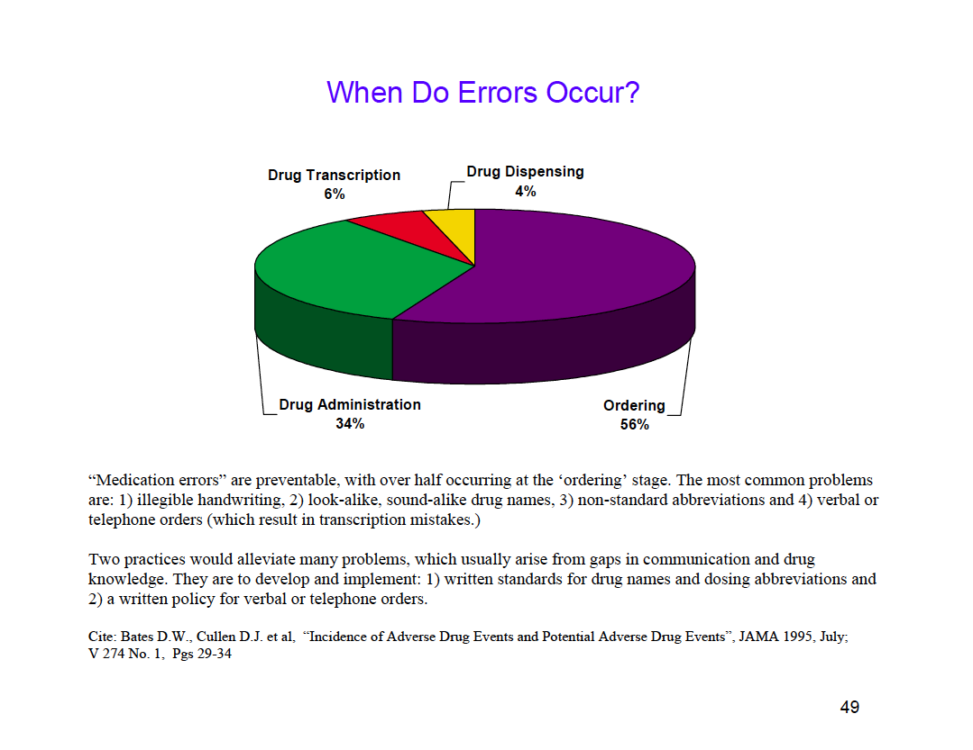
“Medication errors” are preventable, with over half occurring at the ‘ordering’ stage. The most common problems are: (1) illegible handwriting, (2) look-alike, sound-alike drug names, (3) non-standard abbreviations and (4) verbal or telephone orders (which result in transcription mistakes.)

Two practices would alleviate many problems, which usually arise from gaps in communication and drug knowledge. They are to develop and implement:

(1) written standards for drug names and dosing abbreviations, and

(2) a written policy for verbal or telephone orders.

Source: Bates D.W., Cullen D.J. et al, “Incidence of Adverse Drug Events and Potential Adverse Drug Events”, JAMA 1995, July; V 274 No. 1, Pages 29-34. [Note: Although this is not international data, it is fairly applicable around the world.]

Sample Medication and Allergy Record

Drug interactions and allergies also contribute to medication error. The medication and allergy record should be updated at every patient visit.

The sample form below tracks all of the relevant information:

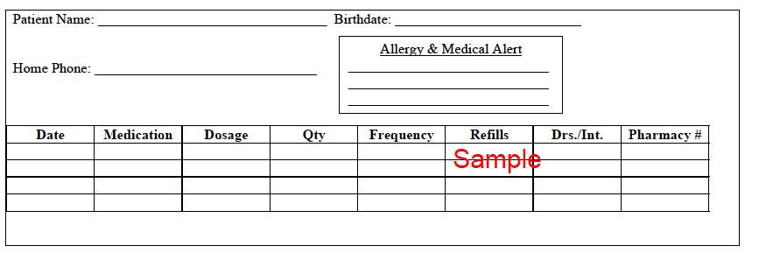

Privacy and Confidentiality

To safeguard private health information, practices should develop and implement a written policy to guide staff. In addition, every employee should read and sign an “employee confidentiality statement,” in which they pledge to protect personal patient information.

Instructions: Work with your table group to review the case below and answer the questions that follow.

Case: Confidential Information

Mrs. Jones was sitting in the waiting room. The clinician came out of an examining room and spoke to the receptionist, saying: “Please make sure to order the HIV screening for Mrs. Smith.” Mrs. Jones was able to hear the conversation. Mrs. Jones is Mrs. Smith’s neighbor.

Questions:

1. How do you ensure that other patients cannot overhear conversations when the clinical staff discusses patient information?

2. What are other ways that patient privacy could be violated?

3. How do you sensitize your staff to the issues of privacy and confidentiality?

Risk Management Case: Dr. Evans Kwendo

Instructions: Please work with your table group to: (1) identify the major risks that have occurred in Dr. Evans Kwendo’s practice; and (2) develop an appropriate risk response strategy for each of the identified risks.

Dr. Evans Kwendo practices as a pediatrician. After completing his university studies, he was employed at a large hospital with branches across Kenya. He worked at the hospital’s branches in Kisumu, Bungoma, and was later moved to the headquarters in Nairobi. He worked there for about 17 years before deciding to resign into private practice.

Dr. Kwendo opened and successfully operated a pediatrics clinic along the busy Jogoo road. Five years into the practice, he got a job with an international NGO as a Child Health Adviser. Since the job was for a period of 5 years, he decided against closing his private practice. Instead, he employed another doctor, Dr. Wamalwa, a general physician, to be in charge of the practice on full time basis.

With the other physician on board, Dr. Kwendo decided to open up the clinic to all people, not just children. Then, using the profits the practice had accumulated over the past five years, he decided to expand the practice by acquiring extra space within the building so they could also provide maternity services.

He chaired a meeting in which he introduced Dr. Wamalwa to the existing staff, comprised of two nurses, an accountant, a receptionist, a cleaner and a messenger. In this meeting, he informed the team that he had landed an international assignment and he was to be based in Lagos, Nigeria, for the next five years. He told them that he would come back to the practice at the expiry of his contract.

Two weeks later, he flew to Lagos to take up his new appointment. While in Lagos, he kept in constant touch with Dr. Wamalwa. On a typical day, they would chat on the phone for at least an hour, with their discussion centered on the operations at the practice and how to better them.

During their conversations, Dr. Kwendo always got an assurance from his colleague that everything was going well and that the practice was operating profitably. Dr. Wamalwa told Dr. Kwendo that he had put in place internal controls to ensure that all monies collected were banked on the same day and that proper books of accounts were kept. He always assured Dr.Kwendo that staff were happy and were looking forward to receiving him once his term with the INGO expired.

At the expiry of his contract, Dr. Kwendo was more than happy to return to Nairobi and continue with his practice. He was so happy that even before going to his house from Jomo Kenyatta International airport, he decided to pass by the practice. He arrived at the practice at exactly 10.00am on a Tuesday. The place was still locked, but there were about five pregnant women seated outside waiting to be attended to once the facility was open. He didn’t understand what was happening. He decided to engage the women in a discussion in the interim.

The women informed him that, on a typical day, the facility opened at 12.00 noon and closed at 3.00pm. They said that the doctor came in once a week, as he was busy elsewhere, but he usually sent some young doctor to attend to the patients in his absence. They informed him that the young doctor was usually alone, but sometimes came with a female colleague who acted as the nurse. Dr. Kwendo was shocked! What had happened to the staff I left? The nurses? The accountant? What really happened?

After waiting for about an hour, he decided to call Dr. Wamalwa. The phone rang but was not picked. He tried again, to no avail. He was just about to leave to go to his house when the women informed him that the young doctor had just arrived. Yes, he was the one, the young doctor. He passed the women and Dr. Kwendo without saying a word, opened the main door, and locked himself inside for about 30 minutes before opening it again to let in the patients. All this time, Dr. Kwendo stood utterly silent.

The young doctor called in Dr. Kwendo first. Dr. Kwendo introduced himself as the owner of the facility and explained that he had employed a Dr. Wamalwa to take charge of the practice while he was away on another assignment. The young doctor informed him that, for the past year, he had been employed there by Dr. Wamalwa who was now working in some large private hospital in Nairobi and only came in the evening to collect the money for the day.

In disbelief, Evans then asked where the other staff were. The young doctor informed him that since he had been employed at the clinic, he had never met any other person. Apparently, Dr. Wamalwa had sacked all of them! In shock, Dr. Kwendo then turned to the young doctor to find out what his training was. He informed him that he was just about to complete his final year at the medical school. “What! You have not even graduated from the university? “Dr. Kwendo wondered loudly.

He could not believe that a practice he had labored to establish could just go down like that. Angrily, he asked the young doctor to give him the keys and all records and leave. There were no records, no patient files. The young doctor only had a listing of daily cash collections on loose pieces of paper. He handed these papers to Dr. Kwendo and left.

The women outside became annoyed, wondering why the doctor was leaving them unattended. They followed him, but he referred them to Dr. Kwendo, saying: “See the owner inside, ”and off he went.

Dr. Kwendo came out to apologize to the women, informing them that the doctor would not see them on that day. Disgruntled, the women left vowing not to come back to this facility. Dr. Kwendo then locked himself inside the facility to inspect it with tears in his eyes. He got out his phone to look up the contact information for the nurses and the accountant he had left at the practice. He only managed to retrieve the accountant’s number. He called him.

The accountant was so glad to know that it was Dr. Kwendo calling. He informed Dr. Kwendo that Dr. Wamalwa had sacked him because he always insisted on taking all the day’s collections to the bank. The nurses had left when they realized that Dr. Wamalwa was only interested in taking away the money. The nurses were the ones who were attending to the patients, but Dr. Wamalwa always came back in the evening to take the collections. He expressed his willingness to come back to work now that Dr. Kwendo was around, but vowed never to work with Dr. Wamalwa. He explained to him that he had handed over all the accounting records to Dr. Wamalwa.
By the end of the call, Evans was furious. He decided to walk around the facility just to take stock of what he had lost. At the reception desk, broken chairs had been heaped in a corner, the reception table was covered in dust and the floor tiles were all worn out. The water in the dispenser had turned green and the telephone set had been removed. Glasses on the main door were either broken or had major cracks. The statutory license on the reception wall was for the previous two years. He could not find his own practicing certificate, which he had left neatly hanging at the reception. He noticed a few patient files just lying on the floor.

His next stop was the records room, which was a shadow of its former self! The lock on the door was broken and so the door had been left open. A big rat dropping from the shelves almost fell on his head, but he ducked. He was so scared. All the files had been torn and papers eaten by rats and cockroaches and the room smelled awful. The doctor’s room had one worn out chair on which patients sat. The inspection bed had a mattress with no cloth, only worn out sponge. He wondered what might have happened.

The drug store was worse. Syringes, needles, and capsules were strewn all over the floor. What! All the drugs in the store had expired: both tablets and syrup drugs had lost their original color. The store was damp with its roof leaking.

It appeared to Dr. Kwendo that he had lost all of his investment! He blamed himself for accepting an appointment out of Kenya. He blamed himself for trusting somebody else to take charge of the facility without supervision. He locked up the place and went to his house writhing in agony with a terrible headache and in utter disbelief. He wanted to sleep on what he had seen so that the following day he could chart the way forward.

Risk Management Assessment for Dr. Evans Kwendo

Risk | Response Strategy

Risk Management and Quality Improvement

Instructions: Please determine whether you agree or disagree with each statement, and be prepared to explain your rationale.

Agree Disagree

1. Risk management is a part of quality improvement. ___ ___

2. Risk management feeds error data into quality
improvement. ___ ___

3. Quality improvement goes beyond risk management. ___ ___

The Next Step

Instructions: We have discussed a number of situations today that could have been avoided if proactive risk management had occurred.
You now need to take some proactive risk management actions:

1. Identify the three most significant risk management issues that could have negative consequences for your practice.

2. Determine the actions you will take to decrease the risk that these three issues will harm your practice.

3. Define the new or supplemental training your staff requires to better manage risk in your practice.

My Key Takeaway

Instructions: Please stand up when you have completed this sentence:

My key takeaway from this session is:

Evaluation Sheet

Instructions: Please answer the questions below as completely and constructively as possible. Thank you!

Strongly Neither Strongly
Agree Agree nor Disagree
This training: Disagree
covered the content as advertised 5 4 3 2 1
was logical and effective 5 4 3 2 1
provided information I can apply in my work 5 4 3 2 1 included useful handouts for future reference 5 4 3 2 1

The facilitator:
was knowledgeable 5 4 3 2 1
was effective 5 4 3 2 1
stayed on topic and on time 5 4 3 2 1

As a result of this workshop, I am better able to:
define risk management; 5 4 3 2 1

assess the need for telephone protocols; 5 4 3 2 1

create a credentialing checklist; 5 4 3 2 1

review the consequences when the six rights of
medication management are not fulfilled; 5 4 3 2 1

describe my privacy and confidentiality practices; 5 4 3 2 1

propose how to handle risk management issues; 5 4 3 2 1

discuss the relationship between risk management
and quality assurance and improvement in a health
practice; 5 4 3 2 1

Excellent Average Poor
Overall, I would rate this training: 5 4 3 2 1

I would recommend this training to a colleague: ___ Yes ___ No
Personal Significance of Workshop:

Of the ideas or techniques covered, I think that these will be of most use to me:

Recommendations for Improving the Training:

Additional Comments:

DISCLAIMER
The author’s views expressed in this publication do not necessarily reflect the views of the United States Agency for International Development or the United States government.

