Business for Health
Business Skills for Private Medical Practices
_____________________________________________________________________________________________________________________

Participant’s Manual

Module 14: Understand the Importance of Financial Information




Table of Contents

Welcome
3 Agenda and Learning Objectives
4 Introductions

Your Current Record Keeping System
5 What You Currently Do With Your Financial Records

Effective Record Keeping Systems
6 Financial Record Keeping Best Practices
8 Examples of Journals
9 Example of an Accounts Receivable Ledger
10 Example of a General Ledger
11 Example of Sales Journal-Sales Ledger-General Ledger
12 Ledgers of Value to Your Practice

Income Statements and Profitability
13 Income Statements
14 Analyzing Income Statements
16 Case: Prof. Michael Olach

Balance Sheets and Equity
18 Balance Sheets
19 Example of a Balance Sheet
20 Got Any Equity?
21 Balance Sheet for Koffi Julius Medical Centre

Questions to Ask Your Accountant
24 What You Need to Know About Your Finances

Working with Financial Information
25 Case: Munyori Herbal Clinic

Summary and Evaluation
27 The Next Step
28 My Key Takeaway
29 Evaluation Sheet

Financial Management for Your Practice
Understand the Importance of Financial Information

Agenda:
- Welcome
- Your Current Record Keeping System
- Effective Record Keeping Systems
- Income Statements and Profitability
- Balance Sheets and Equity
- Questions to Ask Your Accountant
- Working With Financial Information
- Summary and Evaluation
- Close

Learning Objectives: During this workshop, you will:

- Assess your current financial record keeping system;
- Discuss the components of an effective financial record keeping system;
- Identify the financial records your practice should keep;
- Analyze an income statement;
- Determine the value of a balance sheet;
- Plan questions to ask your bookkeeper/accountant on a regular basis;
- Propose how to handle issues involving financial information;
- Discuss the next step; and
- State your key takeaway from the session.

Introductions

Instructions: Please introduce yourself to the group:

1. Your name
2. Your job title
3. Your business
4. How long you have had your business

What You Currently Do With Your Financial Records

Instructions: Working independently:

1. Review the “financial documents” you have been given.

2. Label an envelope or file folder to reflect the current way your practice files
or organizes these financial documents.

3. Place all of the relevant financial documents into the appropriate envelope or file folder.

4. If there are certain pieces of information that your practice does not retain,
label an envelope or file folder as “trash” and place those documents in it.

Financial Record Keeping Best Practices

The foundation for accurate financial statements is a comprehensive record keeping system. First, you need to have all of the financial documents. Next, you have to have a way to capture that information in some organized fashion. This will enable your bookkeeper/accountant to summarize the information and put it into a financial statement, such as a cash flow statement.

The simplified map of basic record keeping below demonstrates what a general accounting system should look like:

Business Transaction
Daily Journal
Ledger
Accounts
Financial Statements

A business transaction is any dealing that involves money- either going into or out of the practice. Transactions are entered into a journal.
A journal is the daily diary that records all the transactions that occur in the business. The transaction is entered in the journal by date, amount, description and account to which the transaction has been assigned.
A ledger is a book of accounts in which each different transaction type is separately maintained. You will record specific information about each type of business activity (for example, sales and purchases) in books called ledgers.

The number of ledgers used depends on the size of the clinic and the kind of business that is conducted. Information from the ledgers is used to create financial reports.

Typical types of ledgers include:

- Sales ledger. This is a record of your sales invoices.

- Accounts Receivable. When you sell goods and services, and the client agrees to pay later, that is, on credit. This is also called a debtors’ ledger.

- If you have corporate credit clients or insured clients, you should keep corporate account or insurance ledgers. To maintain this kind of ledger, each account/insurance company should have a separate page for their account. This way you can easily track sales and payments for each account.

- Accounts Payable. When you purchase goods and services, but do not pay for them at the time of purchase, you will record the amounts you owe and when they are due in an accounts payable ledger.

- If you have an inventory of goods and products, you will depend on a stock or materials ledger to tell you how many units you have available on a given day.

- For equipment or vehicles your business owns, you should use an equipment ledger to report their costs. This journal will also show you the total value of your business's equipment.

- Wages or labor ledger to record payments to staff. When your business is big enough to employ extended family members or outside employees, you will keep a record of payments to these people in a wages ledger.

- A cash ledger. This specialized record book will provide the details of your cash sales and payments. It will be described in more detail later.

Examples of Journals
Sales Journal
Date | Sale No. | To Whom Sold | Post. Ref. | Accounts Receivable Debit | Sales Credit | Sales Tax Payable Credit
April 1 | 900 | A. Smith |  | $1,000.00 | $940.00 | $60.00
April 1 | 901 | B. Johnson |  | $2,000.00 | $1,880.00 | $120.00
April 1 | 902 | C. Chang |  | $1,000.00 | $940.00 | $60.00
April 4 | 904 | D. Garcia |  | $1,000.00 | $940.00 | $60.00
Cash Receipt Journal
Date | Account Credited | Post Ref. | General Credit | Accounts Receivable Credit | Sales Credit | Sales Tax Payable Credit | Cash Debit
May 1 | B. Johnson |  |  | $1,000 |  |  | $1,000
May 3 | C. Chang |  |  | $1,000 |  |  | $1,000
May 5 | A. Smith |  |  | $1,000 |  |  | $1,000
May 8 | Interest Receivable |  |  | $400 |  |  | $400
Purchases Journal
Date | Invoice No. | From Whom Purchased | Post Ref. | Purchased Debit / Accounts Payable Credit
June 2 | 6321 | BCD Corp. |  | $12,000
June 5 | 12D | Telecom8 Inc |  | $800
June 21 | 412 | Furniture-X |  | $2,000
Cash Payments Journal
Date | Check No. | Account Debited | Post Ref. | General Debit | Accounts Payable Debit | Purchases Credit | Cash Credit
July 1 | 1254 | Rent Expense |  | $1,200 |  |  | $1,200
July 2 | 1255 | BCD Corp. |  |  | $12,000 |  | $1,200
July 2 | 1256 | Furniture-X |  |  | $1,200 |  | $1,200

Example of an Accounts Receivable Ledger
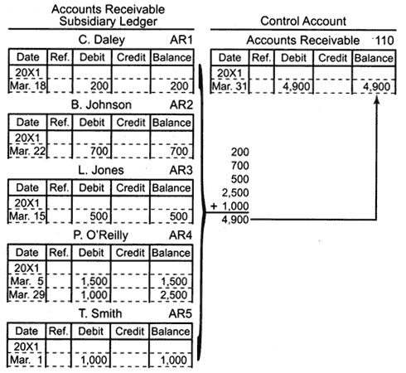

Example of a General Ledger

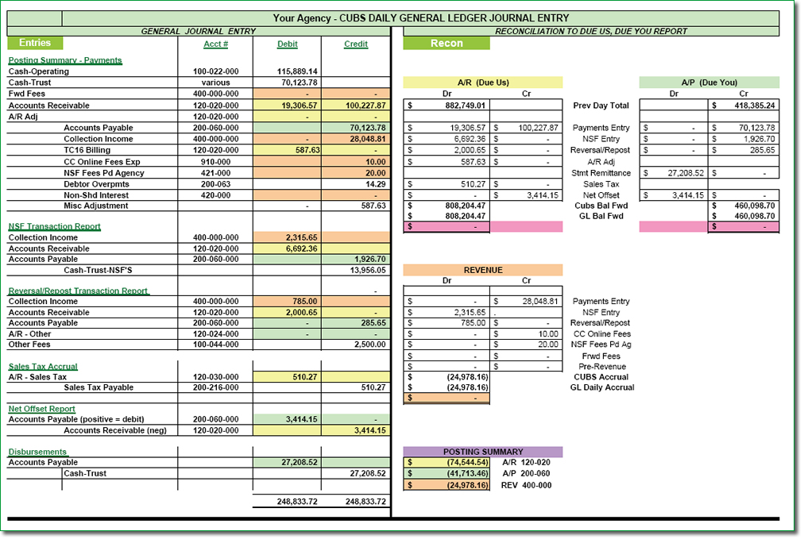

Example of Sales Journal - Sales Ledger- General Ledger

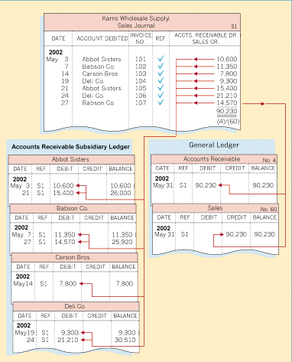
Ledgers of Value to Your Practice

Instructions: Please answer the questions below:

- What ledgers would be useful for your practice to keep?

- How might having this information change the way you manage your practice?

- What financial statements do you or your bookkeeper/accountant generate, drawing the information from the ledgers?

Income Statements
An income statement shows all revenue and expense accounts over a period of time. It is also referred to as a profit and loss statement (or P & L). From an income statement you can determine how much money your business made after all expenses are accounted for, i.e., how much profit you made.
The basic format is that all the income sources are listed and totaled on the top of the statement, and all the expenses are listed and totaled next. The total of the expenses is subtracted from the total of the income to give the profit over that time period.
Example of an Income Statement
Which categories of revenue and expense are relevant for your practice?
Analyzing Income Statements

Instructions: Review Income Statement A below:

1. Does it show a profit or a loss?

2. What categories on the Income Statement explain the profit or loss?

3. What else does the Income Statement reveal about the practice?

Income Statement A
Instructions: Review Income Statement B below:

1. Does it show a profit or a loss?

2. What categories on the Income Statement explain the profit or loss?

3. What else does the Income Statement reveal about the practice when you
compare it to Income Statement A from the previous month?

Income Statement B

Case: Prof. Michael Olach

Instructions: Working independently, please fill in the blank spaces in the Income Statement for Prof. Michael Olach on the next page, so that you can determine Prof. Olach’s practice net income after taxes for the period ending 31st December 2013.

Prof. Michael Olach

Michael Olach is a renowned HIV and AIDS researcher who also doubles up as a professor of Pharmacology and Therapeutics at a large public university in Kenya. His experience in HIV and AIDS research spans several decades, starting when he was a doctoral student at the University of Hadassah in Israel in the 1970s. Since then, he has conducted break-through research for major multinational drug manufacturers. This research experience led to his appointment as the Chief Government Chemist in the republic of Kenya, a position that he held for 10 years.

Upon his retirement from this position, Prof. Olach registered an international medical foundation under which he has been practicing as an HIV and AIDS specialist. He first set up his clinic in Nairobi in the heart of the central business district, but the pressures of operating in a busy town drove him to transfer his practice to one of his homes located in a serene suburb of Nairobi County. It is here that Prof. Olach runs a very successful practice, specializing in the management of HIV and AIDS patients.

As a responsible citizen, Prof. Olach prepares his practice accounts at the end of every financial year and uses these accounts to make key decisions regarding his operations in the following year. One key account that he makes is the income statement. The partial information on the following page is extracted from his books of accounts for the year ended 31st December 2013:

Income Statement for Dr. Michael Olach

What is net income after taxes for the period ending 31st December 2013?

 | Revenue/Sales: | Ksh. ‘000
1. | From consultation | 6,000
2. | From dispensing drugs | 18,000
3. | Total Revenue (1+2) | ?
 | Cost of Sales:
4. | Opening Stock of drugs | 2,000
5. | Add purchases of drugs | ?
6. | Drugs available for sale (4+5) | 10,000
7. | Less closing stock of drugs | ?
8. | Cost of Sales (6-7) | 5,450
9. | Gross Profit (3-8) | ?
 | Expenses in the Practice:
10. | Salaries (nurses, watchmen, cleaners & gardener) | 2,000
11. | Licenses (practice & statutory) | 100
12. | Stationery | 100
13. | Electricity, water & rates | 80
14. | Depreciation on furniture, fittings, equipment & buildings | 120
15. | Subscriptions | 105
16. | Interest on bank overdraft | 1,000
17. | Total expenses before taxes (10+11+12+13+14+15+16) | ?
18. | Net income before taxes (9-17) | ?
19. | Taxes (30% of income before taxes) | ?
20. | Net income after taxes (18-19) | ?

Balance Sheets

Income statements and cash flow projections offer only one side of the financial picture. You need a balance sheet to actually determine the financial health of your business at a given time.
A balance sheet provides a snapshot of the business's assets, liabilities and owner's equity on a particular date.

Assets are any item of economic value possessed by a business, especially that which could be converted to cash. Examples are cash, accounts receivable, inventory, equipment, real estate, a vehicle, and other property. Assets that can be converted to cash within one year are called current assets. Assets that are not easily converted to cash are called fixed assets.

Liabilities are obligations that legally bind a business to settle a debt. A liability can include accounts payable, taxes, wages, accrued expenses, and deferred revenues. Short-term liabilities are debts payable within one year, while long-term liabilities are debts payable over a longer period, such as bank or investor loans.

Equity is total assets minus total liabilities. It indicates the financial health or net worth of a business.

Example of a Balance Sheet

Got Any Equity?

Instructions: Working with your table group, please review the case study below and answer the questions on the next page.

Case Study: Koffi Julius Medical Centre

Dr. Koffi Julius has given you the following financial information for last month for his medical practice, Koffi Julius Medical Centre.

1. Cash balance brought forward 30,000

2. He attended to 20 clients and charged each of them 3,000

3. 15 of the clients paid cash immediately, while the remaining 5 were allowed credit. No one else owes Dr. Koffi any money.

4. Dr. Koffi bought 10, 000 worth of drugs, adding to his previous inventory of 15,000.

5. His fixed assets are:
- Furniture – 5,000
- Equipment/Vehicle – 15,000
- Building – 10,000
- Land – 10,000

6. He paid 8,000 cash to the suppliers and promised to pay the balance in the following month.

7. Within the month under review, he used drugs worth 6,000.

8. He paid cash for the following expenses:
- telephone charges – 2,000
- stationery – 1,500
- diesel – 3,000

9. He did not pay the following expenses:
- Water rate – 1,500
- Electricity bill – 1,500

10. Dr. Koffi invested 54,000 of his own funds into the Centre.

Questions:

1. What are the accounts that comprise the current assets of the business?

2. How much are they worth in total?

3. What are the fixed assets and how much are they worth?

4. What expenses are yet to be paid (accrued expenses)?

5. What are the total accrued expenses?

6. What business liabilities are yet to be paid (accounts payable)?

7. What are the total business liabilities?

8. If equity = assets – liabilities, how much equity is there in the business?

9. If the owner invested 54,000, how much are the retained earnings?

10. Does this seem financially healthy to you? Please explain your answer.

Balance Sheet for Koffi Julius Medical Centre

Why is it called a balance sheet?
What You Need to Know About Your Finances

Instructions: Working with your new group, please brainstorm the questions that you are going to need to ask your bookkeeper or accountant on a regular basis. Post your group’s questions on a flip chart.

How will you use the answers to these questions?

Case: Munyori Herbal Clinic

Instructions: Working with your table group, please use the information provided below to create an income statement for the Munyori Herbal Clinic. Then, please answer the question that follows the case study.

Munyori Herbal Clinic

Dr. Nang’ayo is contemplating acquiring Munyori Herbal Clinic, which operates in Nakuru County at the heart of the Kenyan Rift Valley. The clinic specializes in small scale manufacturing and dispensing of herbal medicines to patients with common chronic illnesses. The clinic has been in operation for over ten years and receives patients from across Kenya based on its solid experience in provision of herbal medical solutions for patient problems.

The proprietors of Munyori Herbal Clinic have provided Dr. Nang’ayo with a listing of the accounting data, which is shown below. The data relates to the just ended financial year:

Administrative Expense | Ksh. 4,000,000
Administrative Salaries | Ksh. 2,500,000
Advertising Expense | Ksh. 5,000,000
Consulting Expenses | Ksh. 500,000
Direct Labour | Ksh. 14,000,000
Income Tax Rate | 30%
Interest Expense | Ksh. 3,000,000
Manufacturing Overhead | Ksh. 6,000,000
Other Administrative Expenses | Ksh. 1,000,000
Promotional Expenses | Ksh. 5,000,000
Raw Material Expense | Ksh. 38,000,000
Research & Development | Ksh. 4,000,000
Sales | Ksh. 100,000,000

In order to make a decision on whether or not to acquire the clinic, Dr. Nang’ayo wants to determine whether the clinic is operating profitably based on its income statement for the year.
Munyori Herbal Clinic Income Statement
for the Period Ending 31 December 2013
INCOME STATEMENT | Current Month | Last Month
Revenues
TOTAL REVENUES:

Expenses
TOTAL EXPENSES:

NET INCOME BEFORE TAXES (Revenue – Expenses)
TAXES
NET INCOME

Question: Besides profitability, which other factors should Dr. Nang’ayo consider before acquiring Munyori Herbal Clinic?

The Next Step

Instructions: You know the purpose of an income statement and a balance sheet. You also know how important it is to have an accurate and accessible financial record keeping system. Now you need to:
1. Ensure that your financial record keeping system retains all financial
information, records all transactions, and maintains ledgers for significant
accounts.

2. Meet with your bookkeeper/accountant on a regular monthly basis and ask
your questions so that you can monitor the profitability of your practice.

3. Identify at least three things you plan to do differently to improve your
financial record keeping:

a.

b.

c.

My Key Takeaway

Instructions: Please stand up when you have completed this sentence:

My key takeaway from this session is:

Evaluation Sheet

Instructions: Please answer the questions below as completely and constructively as possible. Thank you!

Strongly Neither Strongly
Agree Agree nor Disagree
This training: Disagree
covered the content as advertised 5 4 3 2 1
was logical and effective 5 4 3 2 1
provided information I can apply in my work 5 4 3 2 1 included useful handouts for future reference 5 4 3 2 1

The facilitator:
was knowledgeable 5 4 3 2 1
was effective 5 4 3 2 1
stayed on topic and on time 5 4 3 2 1

As a result of this workshop, I am better able to:
Assess our current financial record keeping system; 5 4 3 2 1

Identify the components of an effective financial
record keeping system; 5 4 3 2 1

identify the financial records that my practice
should keep; 5 4 3 2 1

analyze an income statement; 5 4 3 2 1

determine the value of a balance sheet; 5 4 3 2 1

identify questions to ask our bookkeeper/
accountant on a regular basis; 5 4 3 2 1

propose how to handle issues involving financial
information. 5 4 3 2 1

Excellent Average Poor
Overall, I would rate this training: 5 4 3 2 1

I would recommend this training to a colleague: ___ Yes ___ No

Personal Significance of Workshop:

Of the ideas or techniques covered, I think that these will be of most use to me:

Recommendations for Improving the Training:

Additional Comments:

DISCLAIMER
The author’s views expressed in this publication do not necessarily reflect the views of the United States Agency for International Development or the United States government.

