Business for Health
Business Skills for Private Medical Practices
_____________________________________________________________________________________________________________________

Participant’s Manual

Module 18: Develop an Operating Budget




Table of Contents

Welcome
3 Agenda and Learning Objectives
4 Introductions

Introduction to an Operating Budget
5 Definition of an Operating Budget
6 The Elements of an Operating Budget
7 Operating Budget Template

How to Analyze a Budget
8 Budget Comparison for St. Joseph’s Clinic
9 Budget Analysis Questions
11 Why an Operating Budget is Important

How to Build an Operating Budget
12 Steps for Building an Operating Budget
14 Operating Budget Template
15 Case: Dr. Andrew Owala
17 Operating Budget for Dr. Owala

How to Make Sales Projections

18 Forecast and Plan Your Sales
19 An Example of Poor Forecasting
20 Avoiding Forecasting Pitfalls
22 Making Sales Projections
25 Sales Projection Methods
28 Make a Sales Projection for Dr. Owala
29 Sales Projection for Dr. Owala

Summary and Evaluation
30 Next Step
31 Operating Budget Template
32 My Key Takeaway
33 Evaluation Sheet

Financial Management for Your Practice
Develop an Operating Budget

Agenda:
- Welcome
- Introduction to an Operating Budget
- How to Analyze a Budget
- How to Build an Operating Budget
- How to Make Sales Projections
- Summary and Evaluation
- Close

Learning Objectives: During this workshop, you will:

- Define what an operating budget is;
- Describe the elements of an operating budget;
- Analyze a budget;
- Discuss how to construct an operating budget;
- Create an operating budget;
- Make a sales projection;
- Discuss the next step; and
- State your key takeaway from the session.

Introductions

Instructions: Please introduce yourself to the group:

1. Your name
2. Your job title
3. Your business
4. How long you have had your business

Definition of an Operating Budget

Instructions: Please review the sample operating budget below and then volunteer your answer to the question:

What is an operating budget?

The Elements of an Operating Budget

- Period: The time period for which you are constructing your budget. It is common to do an annual budget, broken down by month, especially if your business has seasonal fluctuations.

- Categories: There are two main categories: expenses and revenue.

You may want to divide your expenses into two categories: fixed expenses and variable expenses.

- Fixed expenses are those that occur each month and they do not change with sales volume, for example, rent or phone bill.

- Variable expenses are those that change according to volume of business, for example, the cost of drugs or supplies may increase during very busy months.

- Projected Amount for Each Category: This is the amount for each category of revenue and expenses that you predict based on your assumptions.

- Actual Amount for Each Category: This is the amount for each category of revenue and expenses that actually occurred in a given period of time. It is used to compare the budget with the actual so that variances can be analyzed.

- Budget Difference (or variance) = Actual Amount – Projected Amount . This
is the difference between what you projected for a specific category and what actually happened.

  - The positive difference for expenses means that your actual expenses were higher than planned and a negative difference means than your expenses were lower.

  - On the revenue side, a positive difference means that you earned more revenue than planned and a negative difference means that your actual revenue is lower than expected.

  - If overall revenues cover the expenses, the budget is balanced; if not, there is a budget shortfall.
Operating Budget Template

Budget for | ______________________________
Period | ______________________________
Budget for St. Joseph’s Clinic, July 2013
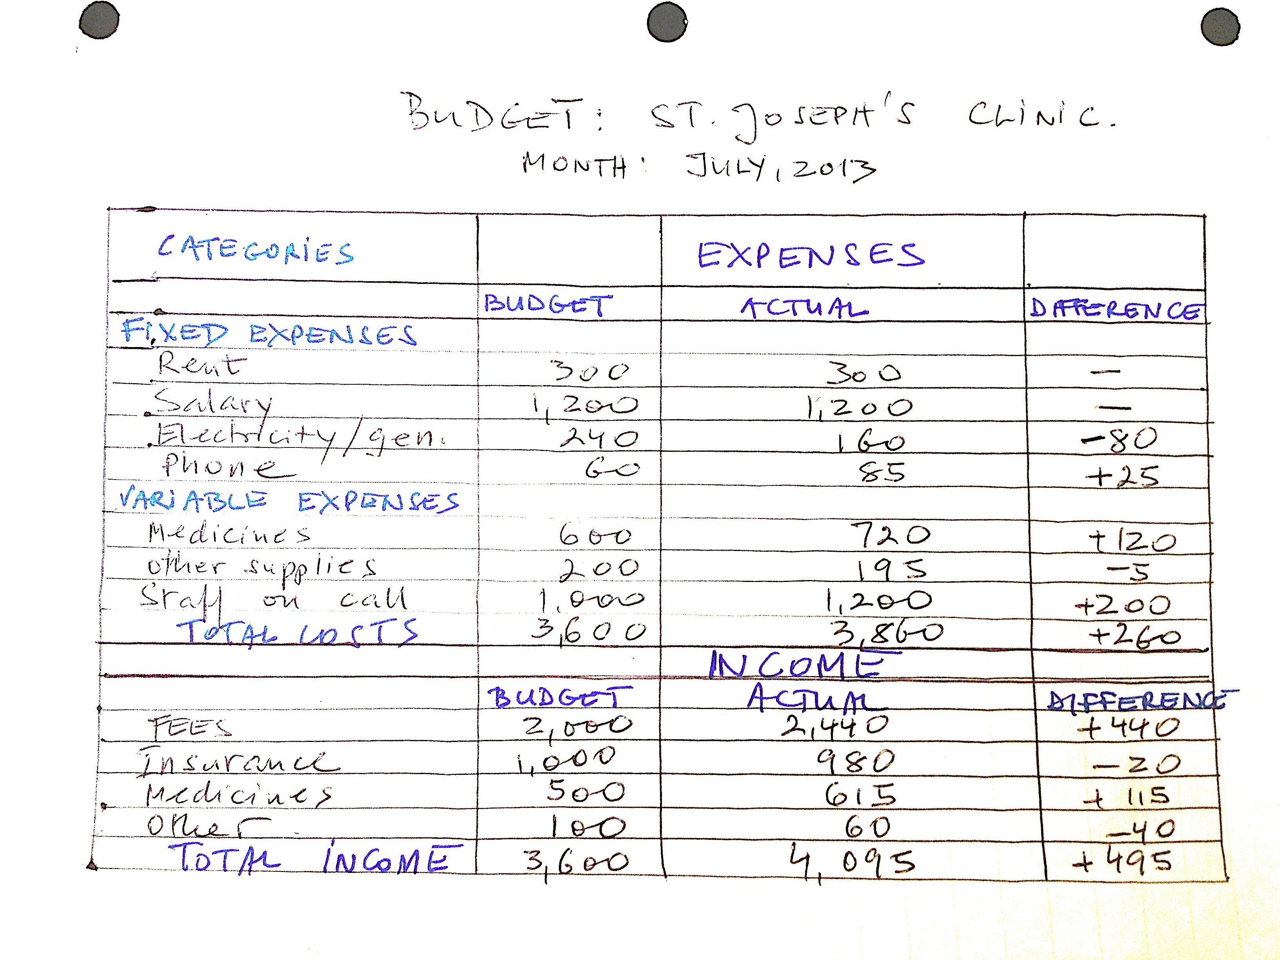
Budget Analysis Questions
Instructions: Working with a partner, please analyze the budget on the previous page and answer the following questions.

Question #1: What budget categories were included in this budget on the:
a. expense side?

b. revenue side?

Question #2:
a. Which actual expenses are higher than budgeted?

b. Which actual expenses are lower than budgeted?

c. What can you say about the overall expenses?

d. Which expenses contribute most to the increase in expenses?

Question #3:
a. Which is larger, the actual revenue or the projected revenue?

b. Which categories of actual revenue differ from the projected revenue?

Question #4: What can you say about the overall budget compared to the actual financial results?

Question #5: What does your budget analysis tell you about this business?

Question #6: What conclusions can you draw for preparing the next month’s budget?

Question #7:
a. Which budget categories should be increased? Explain your answer:

b. Which budget categories should be decreased? Explain your answer:

Question #8: How can this budget help the owner make business decisions?
Why an Operating Budget is Important

Instructions: Volunteer your answers to the question below:

Now that you have analyzed an operating budget,
why is it so important for your practice
to have one?

Steps for Building an Operating Budget

Your budget will be based on your assumptions about your future revenue and expenses. You should make sure that those assumptions as realistic and precise as possible.

- Identify the time period and the extent of detail (whether by quarter or month).

For example, you want to make your budget for a quarter because your business remains pretty much the same each quarter.

- Determine the categories you would like to track.

For example, you want to track fixed and variable costs and revenue from all sources.

- Identify the level of detail for your expenses and revenue that are meaningful and useful for making decisions in your business.

For example, if you want to track new family planning products and services, you may want to separate them by type of contraceptive to see what is most popular and most profitable.

- Divide your expenses into two categories: (a) fixed and (b) variable, and identify each.

For example, your fixed expenses are those that do not change with sales volume (like salaries, electricity and rent) as opposed to variable expenses that do (like medicines and contract labor) .

- Identify your budget categories for revenue.

For example, you want to track your revenue by all sources of income: walk in clients, scheduled clients, referred clients, clients with the national health insurance, clients with the private health insurance, etc.

- Revise the budget template to fit the needs of your business.

For example, you need to add more rows to the revenue section of the budget because you want to know your sources of income in more detail.

7. Make your sales projections.

[Note: We will discuss how to do this in the next section.]

8. Identify your assumptions about your expenses based on your sales projections. Be clear about on what you base those assumptions.

For example, what is the inflation rate? What additional supplies or staff will be needed to accomplish your sales goals?

9. Enter the amount for each category to develop a draft budget.

For example, since your salary will be the same for the whole year (you are not planning to give yourself a raise), you put 1,500 in each month in the Projected Budget category for your salary.

10. Review the draft budget to make sure it captures all the categories of expenses and revenue and correctly reflects your business and your assumptions.

- Cross-check your assumptions and the level of detail to be sure that all items are included in the budget.

- Make sure that the budget is balanced. If your budget is not balanced for a month, you may want to review your assumptions to make sure that your revenue covers your expenses.

11. Finalize the budget:

- Make note of the date when the budget was created and updated last.

- Keep a copy of the budget and your assumptions in your files for future reference.

Operating Budget Template
Case: Dr. Andrew Owala

Instructions: Working with your table group, please review the information below and develop an operating budget.

Dr. Andrew Owala

Dr. Andrew Owala is a consulting dermatologist with many years of experience. He is a visiting consultant for many hospitals in Kenya, but also runs a private practice based at a Doctor’s plaza in a large referral hospital in Nairobi County.

On a typical day, Dr. Andrew sees patients at his private practice between 8.00 am and 11.00 am. He is busy as a consulting dermatologist to various hospitals between 11.00 am and 4.00 pm. He returns to his private practice at 5.00 pm, where he sees all the remaining patients for the day.

Because of his tight schedule, he has employed a secretary who makes patient appointments and informs him from time to time. This secretary also acts as the administrator.

At the beginning of every financial year, Dr. Andrew prepares an operating budget for the coming financial year and uses this budget to control the operations of his private practice. His secretary has training as an accounting technician and therefore guides Dr. Andrew in completing the operating budget. The following information is relevant for the preparation of Dr. Andrew’s private practice operating budget for the coming financial year:

- Given his limited time, Dr. Andrew plans to see a total of 5000 patients for the coming financial year. He based this number on the average number of patients he has seen in the last three years.

- Experience tells him that he will see 30% of the patients in the first quarter of the year, 33% during the second quarter, 27% during the third quarter, and 10% during the final quarter. The number of patients is spread equally among the three months in each quarter.

- Dr. Andrew does not stock or sell drugs in his practice. Instead, he provides patients with prescriptions to purchase drugs at the pharmacy of their choice.

- Patients pay a one-time payment of Ksh. 1,000 each to open a file during their first visit. Dr. Andrew charges Ksh. 3,000 per patient in consultation fees for every visit.

- The administrative secretary’s monthly salary is Ksh. 30,000.

- Rent at the Doctor’s Plaza is paid quarterly in advance. For his practice, Dr. Andrew pays a monthly rent of Ksh. 50,000.

- Electricity, water and rates are paid at the beginning of the following month at the rate of Ksh. 50,000 per month.

- Practicing as well as statutory licenses are renewed on the first day of the year. The total cost of renewing these licenses is Ksh. 100,000.

- Dr. Andrew has taken out office insurance that he pays for in two installments of Ksh. 20,000 at the beginning of the year and Ksh. 30,000 on 1st July.

- He uses his personal car, a Mercedes S-class, which consumes an average of Ksh. 20,000 in monthly fuel. He has a personal driver whom he pays a monthly salary of Ksh. 25,000.

- Dr. Andrew is a member of several professional associations to which he pays annual subscription of Ksh. 30,000 at the beginning of every year.

- Office supplies and other administrative overhead average Ksh. 100,000 per month. These are paid for at the beginning of the following month.

- Dr. Andrew borrowed Ksh. 10,000,000 from Kenya Commercial Bank Ltd. when setting up his private practice. He repays this loan in equal monthly installments of Ksh. 1,000,000. This loan shall be fully repaid by the end of June 2014.

- As of 31st December 2013, his private practice account had a cash balance of Ksh. 1,000,000.
Operating Budget for Dr. Owala
Forecast and Plan Your Sales
Accurately forecasting your sales and building a sales plan can help you to avoid unforeseen cash flow problems and manage your production, staff and financing needs more effectively.
A sales projection is an essential tool for managing a business of any size. It is a month-by-month forecast of the level of sales you expect to achieve. Most businesses draw up a sales projection once a year.
Armed with this information, you can rapidly identify problems and opportunities - and do something about them.
While it's always wise to expect the unexpected, a well-constructed sales plan, combined with accurate sales projecting, can allow you to spend more time developing your business rather than responding to day-to-day crises.
Question: “Does forecasting health services make sense? People get sick randomly and you never know how many patients you may have in a given month.”
Answer: There are some diseases that are seasonal so you know when you can expect more patients. It may be true that people fall sick randomly in other months, but it is also true that you can encourage people to get other services, such as regular checkups. You can also make efforts to increase sales.
For example, you can offer discounted visits to boost sales during a slow month. You cannot predict the future, but you can anticipate it to some degree, plan accordingly and manage your response.
An Example of Poor Forecasting

Instructions: Working independently, please review the case below and identify which forecasting pitfalls on the following pages should have been avoided.

The Urban Draw

Two new oncology residency graduates studied the map of their small country and the distribution of medical specialists. They noted that the third largest town in their country had no oncology specialists. Patients who needed cancer care either traveled to the capital city or to a much larger major metropolitan center in a neighboring country.

The doctors studied the town demographics, estimated the incidence of cancer based on national statistics and decided there would be enough patients to support a practice in town. They were so optimistic about the potential of this un-tapped market that they decided to make the expensive investment in a CT scanner, the first that would be available to local citizens. The doctors borrowed heavily from the bank to build and equip their “Cancer Center.”

What the doctors failed to realize was how ingrained in the culture of the town was the idea that “the best” care could only be found in the capital city. In the past, the local residents had never been able to get the quality of care that they could receive in “the city.” It was commonly believed that only sub-par doctors, who were unable to find good positions in the city, set up specialty practices in small towns.

Refusing to believe that the new young specialists in town could be good doctors, their potential patients continued to travel to the capital city. It took years longer than forecasted for the new oncologists to build their practice and re-pay the loan on their CT Scanner.

Avoiding Forecasting Pitfalls
There are five common forecasting pitfalls that you want to avoid:
1. Engaging in wishful thinking.
It's all too easy to be over-optimistic. It's a good idea to look back at the previous year's forecast to see if your figures were realistic. New businesses should avoid the mistake of working out the level of sales they need for the business to be viable, then putting this figure in as the forecast.
You also need to consider if it is possible to achieve the sales levels you're forecasting with the resources you have. For example:
- one doctor can only attend to a certain number of patients each day
- an x-ray machine can only be used by a given number of patients
- one salesperson in a pharmacy can serve only a certain number of customers each day
2. Ignoring your own assumptions.
Make sure your sales assumptions are linked to the detailed sales projection, otherwise you can end up with completely contradictory information. For instance, if you assume a declining market, it's illogical to then forecast increased sales.
3. Continually changing your goals.
Make sure the forecast is finalized and agreed within a set timeframe. If you're spending a lot of time refining the forecast, it can distract you from focusing on your targets. Avoid making excessive adjustments to the forecast, even if you discover it's too optimistic or pessimistic.

4. Not consulting your staff or customers
Your staff probably has the best knowledge of your customers and your market, therefore:
- ask for the staff’s opinions
- consider surveying your customers
5. Not getting feedback
Having built your sales projection, you need someone to challenge it. Get an experienced person - your accountant for example - to critically review the document.

Making Sales Projections
1. The starting point for your sales projection is last year’s sales.

This is the base that you will adjust according to your assumptions about the future. The best predictor of how you will perform the next year is the way you performed during the most recent year.

However, you need to critically review your last year’s sales to check if it was a typical or an atypical year in your practice. This will help you to determine how useful last year’s sales would be as a good basis to project future sales.
These questions may help to clarify your position:
- How many new patients do you gain each year?
- How many patients do you lose each year?
- What is the average number of services you give to patients?
- Are there particular months where you acquire or lose more patients than usual?
- Do you know of any patients who are going to need more- or less services- from you next year?
- Do you depend on one type or group of clients? How likely are they to be your clients next year?

2. Identify your sales assumptions.
Every year is different, so you need to list any changing circumstances that could significantly affect your sales. These factors - known as the sales projection assumptions - form the basis of your forecast.
Depending on your type of practice, you may want to specify the volume of sales in the forecast - for example, how many medical procedures you will perform, how many patients under health insurance you will see - as well as the price of each service. By knowing the volume, you can plan the necessary resources in areas such as staffing or storage.
Quantify the expected changes - as shown in the examples below. You can then get a feel for the impact it will have on your business. Also, give the reasoning behind each figure, so that other people can comment on whether it's realistic.
These are some examples of typical assumptions:
The market:
- The market you sell into will grow by 2 per cent.
- Your market share will shrink by 2 per cent, due to the success of a competitor.
Your resources:
- You will double your staff from three people to six people, halfway through the year.
- You will spend 50 per cent less on advertising, which will reduce the number of enquiries from potential customers.
Overcoming barriers to sales:
- You are moving to a better location, which will lead to a 30% increase in customers next year.
- You are raising prices by 10 per cent, which will reduce the volume of products sold by 5 per cent but result in a 4.5 per cent increase in overall revenue.
Your products or services:
- You are launching a range of new products or services. Sales will be small this year and costs will outweigh profits, but in future years, you will reap the benefits.
- You have products or services that are newly established and that have the potential to increase sales rapidly.
- You have established products that enjoy steady sales but have little growth potential.
- You have products or services that face declining sales, perhaps because of a competitor's superior product or service.

3. Develop your projection
You can create your Sales Projection after you have written down the assumptions that will affect sales. This becomes easy once you've found a way to break the forecast down into relevant categories.
- Can you break down your sales by product, service, market, or geographic region?
- Do you want to create more than one scenario according to whether your assumptions are optimistic, realistic or pessimistic?
By predicting sales from the “bottom up”, you're forecasting what you think will be sold by category, including volume price. This is generally far more accurate than forecasting from a target figure and then trying to work out how to achieve it.
Sales Projection Methods

Unit Price Method (for Products or Services)
Add up all the individual sales projections for each product or service sold by your business to obtain an overall forecast.
- List all the product or services you plan to sell.

For example: You plan to perform IUD procedures.

- Estimate the number of units to be sold for each type – be clear what a unit means; for example, a patient, a particular service, etc.
For example: 40 IUD procedures per month.
- Determine the price for each product or service.
For example: 20 per IUD procedure.
- Develop a sales projection for each unit.
(Unit sales projection = Number of units sold x Price per unit)

For example: 40 IUD procedures x 20 per procedure = 800 is the total sales projection.

- Total the sales projections for all units to obtain an overall sales estimate.

Sales Method (for Products or Services)
If the business has many items in inventory, the unit method may not be very practical. Instead of counting each product, divide the business into categories or departments, and then forecast the sales in each area to obtain the total sales projection.
- List all the categories or departments.

For example: Three departments: family planning, maternal and child health, and general medical consultations.

- Estimate the number of sales for each category or department.

For example: 1600 sales for family planning, 3200 sales for maternal and child health, and 4200 sales for general medical consultations per month.

- Total the sales projections for all categories or departments to obtain an overall sales estimate.
For example: 1600 + 3200 + 4200 = 9000 is the overall sales estimate.

Margin Method (for Products)
If you use the same mark-up on your products sold, say 30%, and if you can assume that inventory will be sold within a period (e.g., a year)- you can estimate your sales projection by adding a mark-up percentage to the value of the inventory you purchase for resale.
The formula for the calculation is:
Estimated sales projection =
(total cost of stock x mark-up)/ (100 + total cost of stock)
For example:
- Stock = $1,000
- Mark up = 50%
Estimated Sales = ($1,000 x 50)/100 + $1,000 = $1,500
Make a Sales Projection for Dr. Owala

Instructions: Working with your table group, please review the information below and prepare the 2015 sales budget for Dr. Andrew Owala’s private practice.

Dr. Andrew Owala

Suppose that during the year 2014, the actual number of patients that attend Dr. Owala’s clinic is 6,000.

This increase in the number of patients means that Dr. Owala will have to redesign the set-up of his clinic to provide for a more spacious waiting lobby at a cost of Ksh. 200,000.

The cost for administrative overhead and office supplies is likely to go up by Ksh. 10,000 per month following this increase in the number of patients.

To cushion the practice against these increased costs, Dr. Owala intends to increase his patient consultation fee to Ksh. 4,000 per patient per visit.

The file opening fee will remain unchanged. All other information remaining as above, prepare the 2015 sales budget for Dr. Andrew Owala’s private practice.

Sales Projection for Dr. Owala

 | Monthly Projected Sales for 2015 |  |  |  |  |  |  |  |  |  |  |  | Total  Ksh. ‘000
 | Ksh. ‘000 |  |  |  |  |  |  |  |  |  |  |  | Total  Ksh. ‘000
 | Jan | Feb | Mar | Apr | May | Jun | Jul | Aug | Sep | Oct | Nov | Dec | Total  Ksh. ‘000
Projected Sales (Number of Patients)
 | Projected Collections from Sales/Patients Ksh. ‘000
Proceeds From File Opening @ Ksh. 1000
Proceeds From Consultation @ Ksh. 4,000
Total Projected Sales/Collections for 2015

The Next Step

Instructions: We have spent this session focused on how to construct, interpret and use an operating budget. You now need to:

1. Capture the past month’s actual expenses and income.

2. Use this information as the starting point for your projected operating
budget.

3. Establish a time period for your operating budget. Your budget should reflect
the nature of your business. If your practice is predictable and stable, you can
set the budget for three months. If your practice is more erratic or seasonal,
it is better to set the budget for six months to get a broader, more accurate
picture.

4. Create an operating budget for your practice. A budget template for the first
quarter is provided on page 28.

5. At the end of each month, enter the actual results and calculate the
differences between the projected and the actual budget.

6. Determine the reasons for the differences between the actual and the
projected expenses and income- and make decisions using this information.

If a temporary need or event caused the difference, there is no need to
adjust for it in your next budget. However, if the difference is due to
something that may have long term consequences, then take that into
account when you create your next budget.

Operating Budget Template
My Key Takeaway

Instructions: Please stand up when you have completed this sentence:

My key takeway from this session is:

Evaluation Sheet

Instructions: Please answer the questions below as completely and constructively as possible. Thank you!

Strongly Neither Strongly
Agree Agree nor Disagree
This training: Disagree
covered the content as advertised 5 4 3 2 1
was logical and effective 5 4 3 2 1
provided information I can apply in my work 5 4 3 2 1 included useful handouts for future reference 5 4 3 2 1

The facilitator:
was knowledgeable 5 4 3 2 1
was effective 5 4 3 2 1
stayed on topic and on time 5 4 3 2 1

As a result of this workshop, I am better able to:
define what an operating budget is; 5 4 3 2 1

describe the elements of an operating budget; 5 4 3 2 1

analyze a budget; 5 4 3 2 1

discuss how to construct an operating budget; 5 4 3 2 1

create an operating budget; 5 4 3 2 1

make a sales projection. 5 4 3 2 1

Excellent Average Poor
Overall, I would rate this training: 5 4 3 2 1

I would recommend this training to a colleague: ___ Yes ___ No

Personal Significance of Workshop:

Of the ideas or techniques covered, I think that these will be of most use to me:

Recommendations for Improving the Training:

Additional Comments:

DISCLAIMER
The author’s views expressed in this publication do not necessarily reflect the views of the United States Agency for International Development or the United States government.

