Business for Health
Business Skills for Private Medical Practices
_____________________________________________________________________________________________________________________

Participant’s Manual

Module 7: Manage Medications and Medical Supplies




Table of Contents

Welcome
4 Agenda and Learning Objectives
5 Introductions
6 Medications and Medical Supplies You Keep On Hand

Receiving and Rotating Stock
7 Procedures for Receiving Medications and Medical Supplies
8 Sample Stock Card
9 Receiving Health Commodities

Arranging and Storing Essential Medications
10 How Do You Ensure FEFO?
11 Common Systems for Arranging Essential Medications
12 Special Storage Conditions

Maintaining Stock Records
13 Standard List of Stock Items
14 Stock Record Information
15 Standard Forms Used for Inventory Control
16 Sample Inventory Control Card (Stock Keeping Record)
17 Sample Quarterly Report and Request Form (Consumption Record)

Conducting a Physical Inventory
18 Steps in Conducting a Physical Inventory

Monitoring Product Quality
20 Indicators of Product Quality Problems
23 How to Prevent Damage and Contamination
24 Sample Medication Storage Safety Audit
25 Routine Storeroom Management Task Checklist

Managing Medications and Medical Supplies
27 Case: Charity Children’s Hospital

Inventory Control Systems
29 Manual Inventory Control
31 Computerized Inventory Management

Summary and Evaluation
33 Next Step
34 My Key Takeaway
35 Evaluation Sheet

Operations Management of Your Practice
Manage Medications and Medical Supplies

Agenda:
- Welcome
- Receiving and Rotating Stock
- Arranging and Storing Essential Medications
- Maintaining Stock Records
- Conducting a Physical Inventory
- Monitoring Product Quality
- Managing Medications and Medical Supplies
- Inventory Control Systems
- Summary and Evaluation
- Close

Learning Objectives: During this workshop, you will:

- Identify the types of medications and medical supplies you keep on hand;

- Discuss the importance of the first-to-expire, first-out (FEFO) procedure;

- Explain how to record stock items;

- Describe your approach to conducting an inventory;
- List the indicators of product quality problems;
- Propose how to prevent damage and contamination;

- Decide how to manage issues related to medications and medical supplies;

- Reference information about inventory control systems;

- Explain the next step; and

- State your key takeaway from this session.
Introductions

Instructions: Please introduce yourself to the group:

1. Your name
2. Your job title
3. Your business
4. How long you have had your business

Medications and Medical Supplies You Keep On Hand
Instructions: Working independently, please list the types of medications and medical supplies that you typically keep on hand in your practice:

Procedures for Receiving Medications and Medical Supplies

Instructions: Working with your table group, please identify the basic steps to take when medications and medical supplies are received:

Prior to Receipt | When Received Products are  Damaged or Expired | When Received Products are  Not Damaged or Expired

Sample Stock Card
STOCK CARD
Product: | Depo Provera (Injectable contraceptives) |  |  | Manufacturer: |  |  | Pfizer
Manufactured date: |  | June 15, 20XX |  | Expiry date: |  | December 27, 20XX
Unit of Measurement: |  | Injection (one dose) |  | Batch No: |  | 07128
Cost per item: |  |  | 75 | Selling price per item: |  |  | 150
Re-order level: |  |  | 20
Date | Details |  | In | Out | Balance |  | Staff initials
3 Oct. 2010 | Sold |  |  | 2 | 8 |  | SG
9 Oct. 2010 | Sold |  |  | 1 | 7 |  | SG
10 Oct 2010 | Order placed for 2 |  |  |  |  |  | SG
17 Oct. 2010 | Bought |  | 2 |  | 9 |  | SG
20 Oct. 2010 | Damaged |  |  | 4 | 5 |  | MB
21 Oct 2010 | Order placed for 5 |  |  |  |  |  | MB
23 Oct. 2010 | Sold |  |  | 2 | 3 |  | MB

Receiving Health Commodities

When you receive health commodities—

- Ensure there is sufficient storage space.

- Prepare and clean the areas used for receiving and storing the products.

- Inspect packages for damaged or expired products.

If products are damaged or expired:

- Separate the damaged or expired stock from the usable stock.

- If damage or expiry is discovered while the delivery truck is still at your site,
refuse to accept the products and note the problem(s) on the delivery note.

- If damage or expiry is discovered after the delivery truck has departed, follow your facility’s procedures for handling damaged or expired stock.

If products are not damaged or expired:

- Count the number of units for each product received and compare to issue
voucher.

- Record the date and quantity received on stock card .

- Ensure the expiry date is visibly marked on every package or unit.

- Arrange products in the storage area to facilitate the first-to-expire, first-out (FEFO) procedure.

Source: John Snow, Inc./DELIVER in collaboration with the World Health Organization. Guidelines for the Storage of Essential Medicines and Other Health Commodities. 2003. Arlington, Va.: John Snow, Inc./DELIVER, for the U.S. Agency for International Development.

How Do You Ensure FEFO?

Instructions: Please pop up and stand next to your chair if you have an answer to the question below. Wait until the facilitator calls on you.

What can you do to ensure that you always
dispense the products that will expire first?

Common Systems for Arranging Essential Medications

Instructions: Working with your table group, please: (1) review these four systems for arranging essential medications; (2) identify their pros and cons; and (3) put a check mark to indicate the system you currently use.

Arrangement System | Pros | Cons | My System
1. Alphabetical Order by
Generic Name

2. Therapeutic or
Pharmacologic Category

3. Dosage Form
4. Frequency of Use

Question: Does your system work for you?

Special Storage Conditions

Instructions: Please work independently to answer the questions below. Be prepared to discuss your answers.

Question #1: What are the different reasons why some products need to be
stored in an access-controlled environment?

Question #2: What products need this type of secure storage?

Standard List of Stock Items

Instructions: Fill in the blanks:

The standard list of stock items needs to include all of the products that your practice keeps on hand. This list should identify product specifications, including:

the f __ __ __ it comes in,
how s __ __ __ __ __ it is, and
the q __ __ __ __ __ __ __ it comes in per package.

The list should be updated r __ __ __ __ __ __ __ __ .

Adapted from John Snow, Inc./DELIVER in collaboration with the World Health Organization. Guidelines for the Storage of Essential Medicines and Other Health Commodities. 2003. Arlington, Va.: John Snow, Inc./DELIVER, for the U.S. Agency for International Development.

Stock Record Information

Instructions: Working independently, please put a check mark (✔) in front of each item of information that you collect on your stock records:

The minimal information that should be collected on stock records for medicines and other health products includes:

___ product name/description (including the form [e.g., capsule, tablet, liquid
suspension, etc.] strength, and quantity per package)

___ stock on hand/beginning stock balance

___ expiry dates

___ special storage conditions (e.g., 2°–8°C)

___ receipts

___ issues

___ losses/adjustments

___ closing/ending balance

___ transaction reference (e.g., issue voucher number or name of supplier or recipient).

Depending on the system, stock records might also include additional product information such as:

___ unit prices

___ lot numbers

___ item codes

Source: John Snow, Inc./DELIVER in collaboration with the World Health Organization. Guidelines for the Storage of Essential Medicines and Other Health Commodities. 2003. Arlington, Va.: John Snow, Inc./DELIVER, for the U.S. Agency for International Development.
Standard Forms Used for Inventory Control

Instructions: Working independently, please review the forms used for inventory control that are listed below and be prepared to discuss: (1) which forms you use and (2) how you use them.

A storage and distribution system may not necessarily use all these forms, but it will need forms to record stock keeping data and product transactions.

Standard forms used for inventory control include:

- stock cards

- bin cards

- requisition/issue vouchers

- receiving forms (packing slip/freight bill)

- delivery/issue vouchers

- expired stock disposal forms

- physical inventory forms

- list of approved medicines and prices

- consumption records

On the following pages, you will see two sample forms:

1. Inventory Control Card (stock keeping record)
2. Quarterly Report and Request Form (consumption record)

Source: John Snow, Inc./DELIVER in collaboration with the World Health Organization. Guidelines for the Storage of Essential Medicines and Other Health Commodities. 2003. Arlington, Va.: John Snow, Inc./DELIVER, for the U.S. Agency for International Development.
Sample Inventory Control Card (Stock Keeping Record)

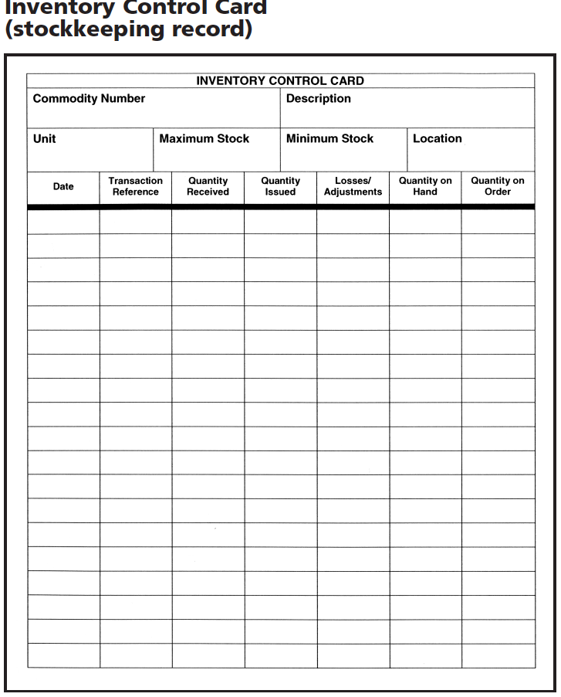

Sample Quarterly Report and Request Form (Consumption Record)

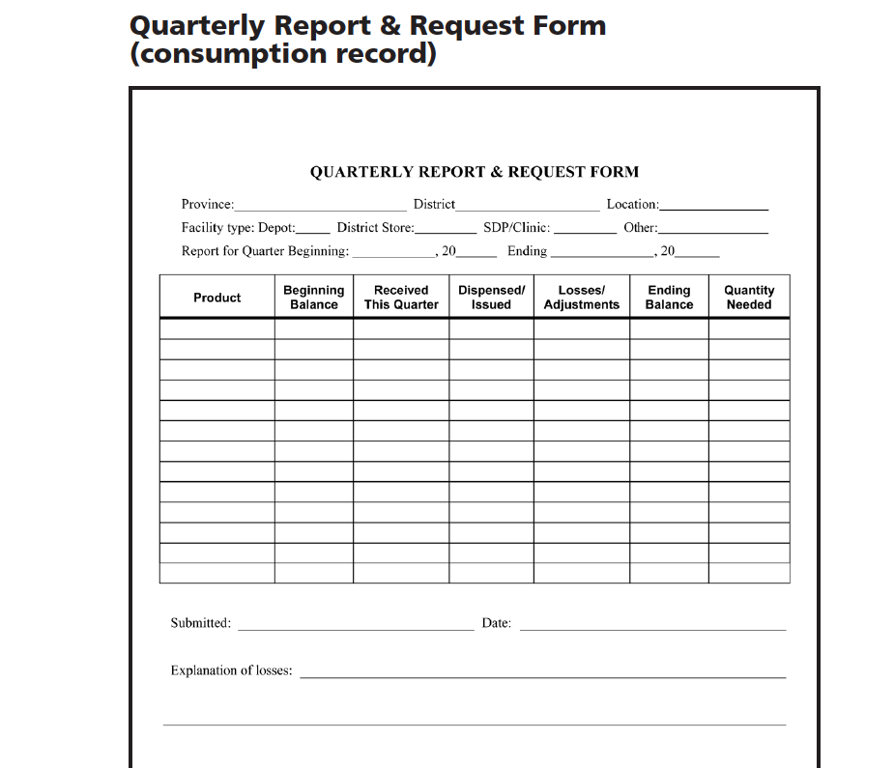

Steps in Conducting a Physical Inventory

Instructions: Please review the steps in conducting a physical inventory below and put a circle around the numbers of the steps that you do not currently implement.

- Plan.

- For a complete physical inventory, schedule the day(s) and time.

- Assign staff.

- Organize the storeroom.

- Arrange products according to FEFO.

- Make sure open cartons and boxes are visible.

- Separate damaged or expired products.

- Count the usable products.

- Count products according to the units by which they are issued (e.g., tablet or piece) not by the carton or box.

- Estimate quantities in open containers for products packaged in bulk. If a bottle of 1,000 capsules is 2/3 full, estimate 650 or 700 capsules. If you have a one-liter bottle of syrup that is 1/2 full, estimate 0.5 liters.

- Update the stock keeping records.

- Write the date of the physical inventory and the words “Physical Inventory.”

- Using a different color ink, write the quantity of the product that you counted during stocktaking.

- Take action based on the results of the physical inventory.

- If the results of the physical inventory differ from the balance on the stock card, update the balance by adding or subtracting the excess or missing quantities.

- Dispose of damaged or expired products found during the physical inventory.

- For either of the above, identify, document, and correct the cause of the problem.

- Discuss the findings of the inventory with the facility staff.

- Congratulate the staff, if appropriate.

- Take corrective actions, if required.

Source: John Snow, Inc./DELIVER in collaboration with the World Health Organization. Guidelines for the Storage of Essential Medicines and Other Health Commodities. 2003. Arlington, Va.: John Snow, Inc./DELIVER, for the U.S. Agency for International Development.
Indicators of Product Quality Problems

Instructions: Products of different types show damage in different ways. Working with your new small group, please: (1) identify indicators you can use to detect damage in each category of product below and (2) what might cause each problem.

Products | Indicators of Quality Problems
All Products:
Liquids:
Light-Sensitive Products (such as x-ray film):
Latex Products:
Products | Indicators of Quality Problems
Lubricated Latex Products:
Pills (tablets)
Injectables:
Sterile Products (including IUDs):

Products | Indicators of Quality Problems
Capsules:
Tubes:
Foil Packs:
Chemical Reagents:
How to Prevent Damage and Contamination

Instructions: Each small group will brainstorm what is required to prevent their assigned cause of damage and contamination: either
physical damage, contamination caused by dirt, damage caused by fire, damage caused by pests, and damage caused by poor temperature control.

Cause of Damage and Contamination:_________________________________

Preventative Measures:

Sample Medication Storage Safety Audit

PATIENT SAFETY AUDIT | Location |  |  | Date:
 | Yes | No | N/A | Comments
STOCK MEDICATIONS
Only authorized medications are present (no excess medications, unauthorized storage areas or unidentified medication).
Medications are locked.
Medications in treatment rooms are locked.
Medications re within their expiration or beyond-use dates.
SAMPLE MEDICATIONS
Sample cabinet/room is locked and accessible only to licensed individuals in the practice.
Medication sample logs are complete.
Samples reflect medications that are appropriate for type of practice.
No controlled substances are present.
CONTROLLED SUBSTANCES
Controlled substances are kept in a double-locked location.
Controlled substances records are complete.
Wastage is reported/documented.
REGRIGERATOR
Refrigerator temperature is between -1° C and 7° C
Note temperature:
Freezer temperature is between -25° C and -15° C
Note temperature:
Refrigerator is clean.
Freezer is frost-free.
High/low thermometer is reset properly.
Refrigerator and freezer logs are complete for every day of this month.
Only medications are stored in this refrigerator and freezer (no food, reagents or specimens).
Refrigerators are locked or in secure area.
Sign indicating “Not for storage of flammables” is present.
MISCELLANEOUS
Single-dose vials are destroyed after one entry.
Multi-dose vials are dated with the date entered and used within 28 days (or shorter period, if appropriate).
Saline syringes are stored appropriately.
Syringes/solutions are labeled if handed to another provider or put down during procedure.

Medical Group Management Association

Routine Storeroom Management Task Checklist

Instructions: Working independently, please review this task checklist and put a check mark [✓] in front of the tasks that you know are completed during the identified timeframe.

Daily/Weekly
___ Monitor storage conditions.
___ Clean receiving, storage, packing, and shipping areas.
___ Sweep or scrub floors.
___ Remove garbage.
___ Clean bins, shelves, and cupboards, if needed.
___ Ensure that aisles are clear.
___ Ensure adequate ventilation and cooling.
___ Ensure that products are protected from direct sunlight.
___ Monitor store security and safety.
___ Check the store roof for leaks, especially during the rainy season and during or after a storm.
___ Monitor product quality (visually inspect commodities and check expiration dates).
___ Ensure that products are stacked correctly (are the lower cartons being crushed?).
___ Update stock records and maintain files.
___ If cycle counting, conduct physical inventory and update stock keeping records.
___ Monitor stock levels, stock quantities, and safety stocks.
___ Submit emergency order (as needed, using local guidelines).
___ Update back-up file for computerized inventory control records.
___ Separate expired stocks and move to secure area.

Source: John Snow, Inc./DELIVER in collaboration with the World Health Organization. Guidelines for the Storage of Essential Medicines and Other Health Commodities. 2003. Arlington, Va.: John Snow, Inc./DELIVER, for the U.S. Agency for International Development.

Monthly
___ Conduct physical inventory or cycle count, and update stock keeping records.
___ Run generator to ensure the system is working correctly; check the level of fuel and add fuel, if needed.
___ Check for signs of rodents, insects, or roof leaks.
___ Inspect the storage structure for damage, including the walls, floors, roof, windows, and doors.

Every 3 months (quarterly)
___ Conduct physical inventory or cycle count, and update stock keeping records.
___ Use established procedures to dispose of expired or damaged products.
___ Visually inspect fire extinguishers to ensure that pressures are maintained and extinguishers are ready for use. Tasks according to reorder interval and reporting schedule (usually monthly or quarterly)
___ Assess stock situation.
___ Complete and submit requisition form.
___ Determine issue quantity and issue products (“push” systems).
___ Receive products.
___ Store products using correct procedures; rearrange commodities to facilitate the first-to-expire, first-out (FEFO) policy.
___ Complete required reporting and documentation.

Every 6 months
___ Conduct fire drills and review fire safety procedures.
___ Inspect trees near the medical store and cut down or trim any trees with weak branches.

Every 12 months
___ Service fire extinguishers and smoke detectors.
___ Conduct complete physical inventory and update stock keeping records.
___ Reassess maximum/minimum stock levels, and adjust if needed.

Case: Charity Children’s Hospital

Instructions: Working with your table group, please review the case information provided below and then answer the questions that follow the case study.

Charity Children’s Hospital

Mrs. Otambo is the mother of Austin, who is a regular client at Charity Children’s Hospital. Mrs. Otambo calls the pharmacy one morning complaining that her son has been dispensed with insulin that had expired the previous month. She also complains that one of the insulin cartridges is half full, showing that it had already been used. She threatens to sue the hospital for negligence.

Kefa, the senior pharmacist on duty, manages to calm her down. He reassures her and requests that she bring the expired cartridges, including the half-filled one, back to the pharmacy. When she comes to the pharmacy, another pack of cartridges with a good shelf life is dispensed to her. Kefa also makes sure to confirm that all of the cartridges were full.

Kefa is not happy about this incident and decides to convene a meeting to conduct a root cause analysis.

The root cause analysis reveals that the expired insulin was received by an intern and not a qualified pharmacy technician or pharmacist, as per policy. It had been a busy Friday afternoon when a supplier delivered the insulin cartridges and one of the technicians had asked an intern to receive them. The intern correctly counted the insulin delivered, but did not document this on the bin card.

Thereafter, the intern was asked to arrange the insulin in the refrigerator shelves. He diligently arranged the insulin based on what he had read about first in, first out, FIFO. However, he did not remember to check the expiry dates. The short expiry insulin cartridges were thus placed at the back of the refrigerator shelves.

The physical stock count process involving checking and documenting the expiry dates of medicines had not been done. As a result, some of the insulin cartridges had expired by the time they were dispensed to clients. It is not known how many cartridges of expired insulin have been dispensed to patients and the team does not know how to go about handling this. One of the pharmacists present in the meeting says that generally all medicines can be used three months post expiry date, but this is not scientifically proven.

Questions:

1. What are the issues in this case?

2. How could these issues have been avoided?

3. What should the pharmacy do now to address these issues?

Manual Inventory Control
by Chris Joseph, Demand Media
Manual inventory systems are susceptible to human error.
Even the smallest businesses need to implement some form of inventory control system to keep an accurate merchandise count, as well as for accounting purposes. Business owners generally have a choice between using a computerized or a manual inventory system. A manual system offers a number of potential advantages and disadvantages.

Simplicity
For a very small business that carries a limited amount of inventory or that turns over inventory slowly, a mechanized inventory system is unnecessary. The business owner can easily keep track of how much merchandise is on hand with a manual system, or simply by applying the "eyeball test" to see if it is time to order more. The owner won't need to spend money on inventory software or take the time to learn how to operate it.

Sense of Control
A manual system gives a small business owner a greater sense of control. Rather than relying on a computer to indicate when it's time to reorder, the owner can manage the process on his own. The need to view his merchandise on a regular basis, such as when counting stock before placing an order, gives him the opportunity to assess the condition of his merchandise, reducing the chance of a customer receiving damaged goods.

Labor-Intensive
A disadvantage of manual inventory systems is that they can be highly labor-intensive to operate. They require continuous monitoring to ensure that each transaction is accounted for and that products are maintained at the appropriate stocking levels. It is also more difficult to share inventory information throughout the business, because the lack of computerization makes accessing inventory records a more cumbersome process. The time spent monitoring inventory levels could be used on more productive activities for the business.

Human Error
A manual inventory system relies heavily on the actions of people, which increases the possibility of human error. People might forget to record a transaction or simply miscount the number of goods. This results in needless additional orders that increase the company's inventory carrying costs and use up precious storage space. Inaccurate physical counts could also result in not ordering enough of a product, meaning the business could run out of a crucial item at the wrong time.

Computerized Inventory Management
by Bonnie Conrad, Demand Media

Computerized inventory systems require more training.
No matter the nature of your business, you need to keep track of the products your firm has on hand. Keeping an accurate inventory is critical to lowering costs and providing a more streamlined operation. As a business owner, you can rely on traditional hand counting methods or institute some form of computerized inventory control. Both approaches have their benefits and drawbacks.

Speed and Efficiency
A computerized inventory management system makes everything from inputting information to taking inventory easier. Doing a hand count of inventory can take days, but with a computerized inventory management system, the same process can be done in a matter of hours.

Document Generation
Once the computerized inventory management system is in place, managers and workers can use it to automatically generate all kinds of documents, from purchase orders and checks to invoices and account statements. Managers can also use the system to automatically order products when they run low.

Timely Data
With a manual system, the data is only as accurate and up to date as the last hand count. With a computerized inventory management system, the management team can pull a report and instantly see how many units are on the floor, how many have sold and which products are selling the fastest.

Reliance on Technology
With a computerized inventory management system, the company is at the mercy of its technology. Outside factors like a power failure or the loss of Internet or network connectivity can render the system temporarily useless.

Accuracy Issues
A computerized system alone does not ensure accuracy, and the inventory data is only as good as the data entry that created it. Companies that plan to use a computerized inventory management system need to have a system in place to validate their data and check the numbers reported by the system. A select hand count or targeted audit may be necessary to ensure the integrity of the system.

Risk of Fraud
Any computerized system carries the risk of intrusion, and with a computerized inventory management system comes the risk of fraud as well. A dishonest vendor could hack the system to receive payment for products never delivered, or a dishonest employee could redirect checks to themselves.

The Next Step

Instructions: You know how important it is to manage your inventory of medications and medical supplies. It is also important to manage the right inventory. You need to:

1. Evaluate whether or not the inventory that you have matches need. Are you stocking the right drugs and supplies? Are
there regular requests for drugs that you don't have in
inventory and that you would be able to stock?

2. Ensure that your inventory of medications and medical
supplies is well-documented, accurate, up-to-date and
properly stored so that medications are dispensed in
accordance with FEFO;

3. Create or confirm a schedule for the performance of storeroom management tasks; and

4. Conduct a medication storage safety audit.

Note: For more detailed information regarding the content covered in this session, please refer to our source material:

John Snow, Inc./DELIVER in collaboration with the World Health Organization. Guidelines for the Storage of Essential Medicines and Other Health Commodities. 2003. Arlington, Va.: John Snow, Inc./DELIVER, for the U.S. Agency for International Development.
http://apps.who.int/medicinedocs/en/d/Js4885e/

If you enter the title under Google, you can find copies under different languages if that would be helpful.

My Key Takeaway

Instructions: Please stand up when you have completed this sentence:

My key takeaway from this session is:

Evaluation Sheet

Instructions: Please answer the questions below as completely and constructively as possible. Thank you!

Strongly Neither Strongly
Agree Agree nor Disagree
This training: Disagree
covered the content as advertised 5 4 3 2 1
was logical and effective 5 4 3 2 1
provided information I can apply in my work 5 4 3 2 1 included useful handouts for future reference 5 4 3 2 1

The facilitator:
was knowledgeable 5 4 3 2 1
was effective 5 4 3 2 1
stayed on topic and on time 5 4 3 2 1

As a result of this workshop, I am better able to:
identify the types of medications and medical supplies
we keep on hand; 5 4 3 2 1

discuss the importance of the first-to-expire, first-out
(FEFO) procedure; 5 4 3 2 1

explain how to record stock items; 5 4 3 2 1

describe our approach to conducting an inventory; 5 4 3 2 1

assess the pros and cons of manual and computerized
inventory systems; 5 4 3 2 1

recognize the indicators of product quality concerns; 5 4 3 2 1

prevent damage and contamination; and 5 4 3 2 1

decide how to manage issues related to medications
and medical supplies. 5 4 3 2 1

Excellent Average Poor
Overall, I would rate this training: 5 4 3 2 1

I would recommend this training to a colleague: ___ Yes ___ No

Personal Significance of Workshop:

Of the ideas or techniques covered, I think that these will be of most use to me:

Recommendations for Improving the Training:

Additional Comments:

DISCLAIMER
The author’s views expressed in this publication do not necessarily reflect the views of the United States Agency for International Development or the United States government.

