Business for Health
Business Skills for Private Medical Practices
_____________________________________________________________________________________________________________________

Participant’s Manual

Module 9: Manage Your Facility




Table of Contents

Welcome
4 Agenda and Learning Objectives
5 Introductions

Facility Management Awareness
6 Discussion Question
7 Four Areas of Facility Management
8 Good Facility Maintenance and Management

Housekeeping
9 What are Your Cleaning Expectations?
10 Facility Cleanliness Standards
15 Hospital and Clinic Cleaning Guidelines

Building and Equipment Maintenance
19 The Equipment Management Cycle
20 Types of Medical Equipment Maintenance
22 Planned Maintenance of Medical Equipment
23 Sample Preventive Maintenance Checklist: Clinical Equipment
24 Sample Clinical Equipment Maintenance Information Sheet
26 The Consequences of Equipment Breakdown
27 Building Self-Inspection

Safety and Security
29 Safe Behaviors Checklist
30 Blood Borne Pathogens
31 Safety Hazards
32 A Sample Monthly Safety Hazard Checklist
34 Security Procedures
35 Possible Security Measures

Waste Management

36 Waste Management
38 Segregation of Medical Waste

Facility Management
39 Case: Northlands Health Center

Summary and Evaluation
43 Next Step
44 My Key Takeaway
45 Evaluation Sheet
Operations Management of Your Practice
Manage Your Facility

Agenda:
- Welcome
- Facility Management Awareness
- Housekeeping
- Building and Equipment Maintenance
- Safety and Security
- Waste Management
- Facility Management
- Summary and Evaluation
- Close

Learning Objectives: During this workshop, you will:

- Discuss what your facility can do to have a positive first impression on your patients and visitors;
- Identify four areas of concern in facility management;
- Rate the cleanliness of your facility;
- Explain basic clinical equipment maintenance procedures
- Review a building maintenance checklist;
- Discuss facility safety issues and procedures;
- Explain your security measures;
- Share waste management methods;
- Propose how to handle issues related to facility management;
- Explain the next step; and
- State your key takeaway from this session.

Introductions

Instructions: Please introduce yourself to the group:

1. Your name
2. Your job title
3. Your business
4. How long you have had your business

Discussion Question

Instructions: Participate with the group in brainstorming answers to the question below:

How is managing a health practice facility
similar to managing a hotel?

Four Areas of Facility Management

Instructions: Review the four areas of facility management that we will focus on today- and see if they are represented in your lists:

1. Housekeeping: Write an “H” next to any housekeeping items

2. Building and Equipment Maintenance: Write “BEM” next to any building or equipment maintenance items

3. Safety and Security (which includes Accessibility): Write “SS” next to any safety, security or accessibility items

4. Waste Management: Write “WM” next to any waste management items

Good Facility Maintenance and Management

Good facilities maintenance and management can:

1. Decrease equipment replacement costs over time.
2. Decrease renovation costs because fewer large-scale repair jobs are needed.
3. Decrease overhead costs (such as utility bills) because of increased system efficiency.

4. Contribute to a medical practice’s effectiveness and financial well-being.

5. Improve the cleanliness, orderliness, and safety of a medical practice’s facilities.

6. Reduce the operational costs and life cycle cost of a building.
7. Extend the useful life of buildings.
8. Increase energy efficiency and help the environment.

What Are Your Cleaning Expectations?

Housekeeping services should help health practices meet their obligation to aid the delivery of high-quality, effective and safe healthcare in clean premises that support the control of healthcare associated infections and make a positive contribution to healthcare outcomes.

Instructions: As you review the cleaning standards on the next few pages, please ask yourself the questions below. Be prepared to discuss your answers with the group.
1. Does my facility meet these standards?

2. Are my cleaning staff aware of these (or any) cleaning expectations?

3. Do my cleaning staff have a schedule and a checklist for cleaning different
areas of the facility?

4. Has my cleaning staff received training regarding the cleaning techniques
and supplies they should use?

5. Do my cleaning staff have the supplies they need to meet these standards of cleanliness?

6. Do my cleaning staff know the basics of infection control and the value of their work in keeping patients and staff from facility-acquired infections?

7. Do my cleaning staff know how to safely handle and dispose of blood and body substances?

8. When was the last time I conducted a facility cleanliness check?

9. How much time do I spend thinking about facility cleanliness?

Facility Cleanliness Standards

Cleaning Standards: Patient Equipment

Direct Contact

 | Element | Standard
 | 1. Toilets and bidets | The toilet and bidet are visibly clean with no blood and body substances, scum, dust, lime scale, stains, deposit or smears.
 | 2. Bathroom safety bars | As above
 | 3. Weighing scales, manual  handling equipment | As above
 | 4. Drip stands | As above
 | 5. Other medical equipment NOT connected to a patient, e.g. intravenous infusion pumps and pulse oximeters | All parts including underneath are visibly clean with no blood and body substances, dust, dirt, debris or spillages.
 | 6. Medical equipment connected to a patient, e.g. intravenous infusion pumps drip stand and pulse oximeters | All parts including underneath are visibly clean with no blood and body substances, dust, dirt, debris or spillages.
 | 7. Patient washbowls | All parts including underneath are visibly clean with no blood and body substances, dust, dirt, debris or spillages.  Patient washbowls are decontaminated appropriately between patients and are stored clean, dry and inverted. Badly scratched bowls are replaced.
 | 8. Medical gas equipment | All parts including underneath are visibly clean with no blood and body substances, dust, dirt, debris or spillages.
 | 9. Patient fans | All parts including the blades/fins and the  underside are visibly clean with no  blood and body substances, dust, dirt, debris or spillages.

Close Contact

 | Element | Standard
 | 10. Exam room accessories | All parts including holder of the alcohol hand wash container are visibly clean with no blood and body substances, dust, dirt, debris or spillages.  Hand wash dispensers are free of product build-up around the nozzle. Splashes on the wall, floor, bed or furniture should not be present

Fixed Assets

 | Element | Standard
 | 11. Switches, sockets and data points | All wall fixtures e.g. switches, sockets and data points are visibly clean with no blood and body substances, dust, dirt, debris, adhesive tape or spillages.
 | 12. Walls | All wall surfaces including skirting are visibly clean with no blood and body substances, dust, dirt, debris, adhesive tape or spillages.
 | 13. Ceiling | All ceiling surfaces are visibly clean with no blood and body substances, dust, dirt, debris, adhesive tape or spillages.
 | 14. All doors | All parts of the door structure are visibly clean so that all door surfaces, vents, frames and jambs have no blood or body substances, dust, dirt, debris, adhesive tape or spillages.
 | 15. All internal glazing including partitions | All internal glazed surfaces are visibly clean and smear-free with no blood and body substances, dust, dirt, debris, adhesive tape or spillages. They should have a uniform shine appearance.
 | 16. All external glazing | All external glazed surfaces are clean.
 | 17. Mirrors | Mirrors are visibly clean and smear-free with no blood and body substances, dust, dirt, debris, adhesive tape or spillages.

 | 18. Ventilation grills  extract and inlets | The external parts of the ventilation grill are visibly clean with no blood and body substances, dust, dirt, debris or cobwebs.

Hard Floors

 | Element | Standard
 | 19. Floor | The complete floor including all edges, corners and main floor spaces should have a uniform shine and be visibly clean with no blood and body substances, dust, dirt, debris, spillages or scuff marks.

Cleaning Standards: Fixtures

Electrical Fixtures and Appliances

 | Element | Standard
 | 20. Pest control devices | The pest control device is free from dead insects, animals or birds and should be visibly clean.
 | 21. Electrical items | The casing of electrical items should be visibly clean with no blood and body substances, dust, dirt, debris or adhesive tape.
 | 22. Cleaning equipment | Cleaning equipment is visibly clean with no blood and body substances, dust, dirt, debris or moisture.

Furnishings and Fixtures

 | Element | Standard
 | 23. Low surfaces | All surfaces are visibly clean with no blood and body substances, dust, dirt, debris, adhesive tape or spillages.
 | 24. High surfaces | All surfaces are visibly clean with no blood and body substances, dust, dirt, debris, adhesive tape or spillages.
 | 25. Chairs | All parts of the furniture are visibly clean with no blood and body substances, dust, dirt, debris, adhesive tape, stains or spillages.
 | 26. Exam Tables | All parts of the table are visibly clean with no blood and body substances, dust, dirt, debris, adhesive tape or spillages.
 | 27. Lockers | All parts of the locker (including wheels, castors and inside) are visibly clean with no blood and body substances, dust, dirt, debris, adhesive tape, stains or spillages.
 | 28. Hand wash containers | All parts of the surfaces of hand soap, paper towel containers are visibly clean with no blood and body substances, dust, dirt, debris, adhesive tape or spillages.
 | 29. Hand hygiene  alcohol rub dispensers | All parts of the surfaces of hand hygiene alcohol rub dispensers are visibly clean with no blood and body substances, dust, dirt, debris, adhesive tape or spillages. Dispensers are kept stocked.
 | 30. Waste receptacles | The waste receptacle is visibly clean including lid and pedal with no blood and body substances, dust, dirt, debris, stains or spillages. Receptacles are emptied frequently and not allowed to overflow.
 | 31. Curtains and blinds | Curtains/blinds are visibly clean with no blood and body substances, dust, dirt, debris, stains or spillages.

Kitchen Fixtures and Appliances

 | Element | Standard
 | 32. Dishwashers | Dishwashers are visibly clean with no blood and body substances, dust, dirt, debris, stains, spillages or food debris.
 | 33. Fridges and freezers | Fridges and freezers are visibly clean with no blood and body substances, dust, dirt, debris, spillages, food debris or build up of ice.
 | 34. Kitchen cupboards | Kitchen cupboards are visibly clean with no blood and body substances, dust, dirt, debris, stains, spillages or food debris.
 | 35. Microwaves | All microwave surfaces are visibly clean with no blood and body substances, dust, dirt, debris, spillages or food debris.

Sinks, Consumables and Soap

 | Element | Standard
 | 36. Replenishment | There are plenty of all consumables and soap.
 | 37. Sinks | The sink and wall-attached dispensers are visibly clean with no blood and body substances, dust, dirt, debris, lime, scale, stains or spillages. Plugholes and overflow are free from build-up.

Adapted from: The NHS Cleaning Manual published by the National Patient Safety Agency, United Kingdom, which is available for download at http://www.npsa.nhs.uk

The Equipment Management Cycle

The maintenance of healthcare equipment is not just a question of repairing broken things. It is an integral part of managing the whole lifecycle of equipment.
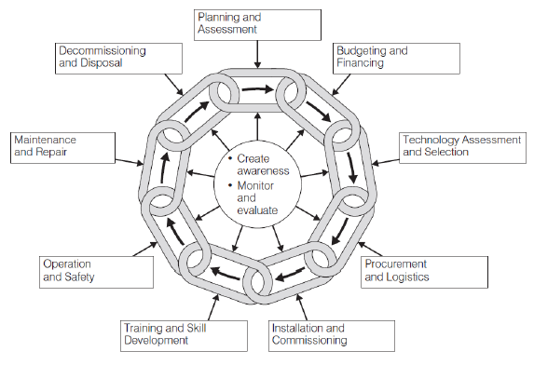
The following diagram illustrates this cycle:
It can be seen that maintenance and repair is just one element.

There are two types of maintenance:
1. Corrective Maintenance (or Repair) is done to take corrective action in the event that the equipment breaks down. The equipment is returned, repaired and calibrated.

2. Planned (or Scheduled) Preventive Maintenance is done in a planned way before repair is required and the scheduled time for the work is circulated well in advance. It involves cleaning, regular function/safety tests, and makes sure that any problems are picked up while they are still small.

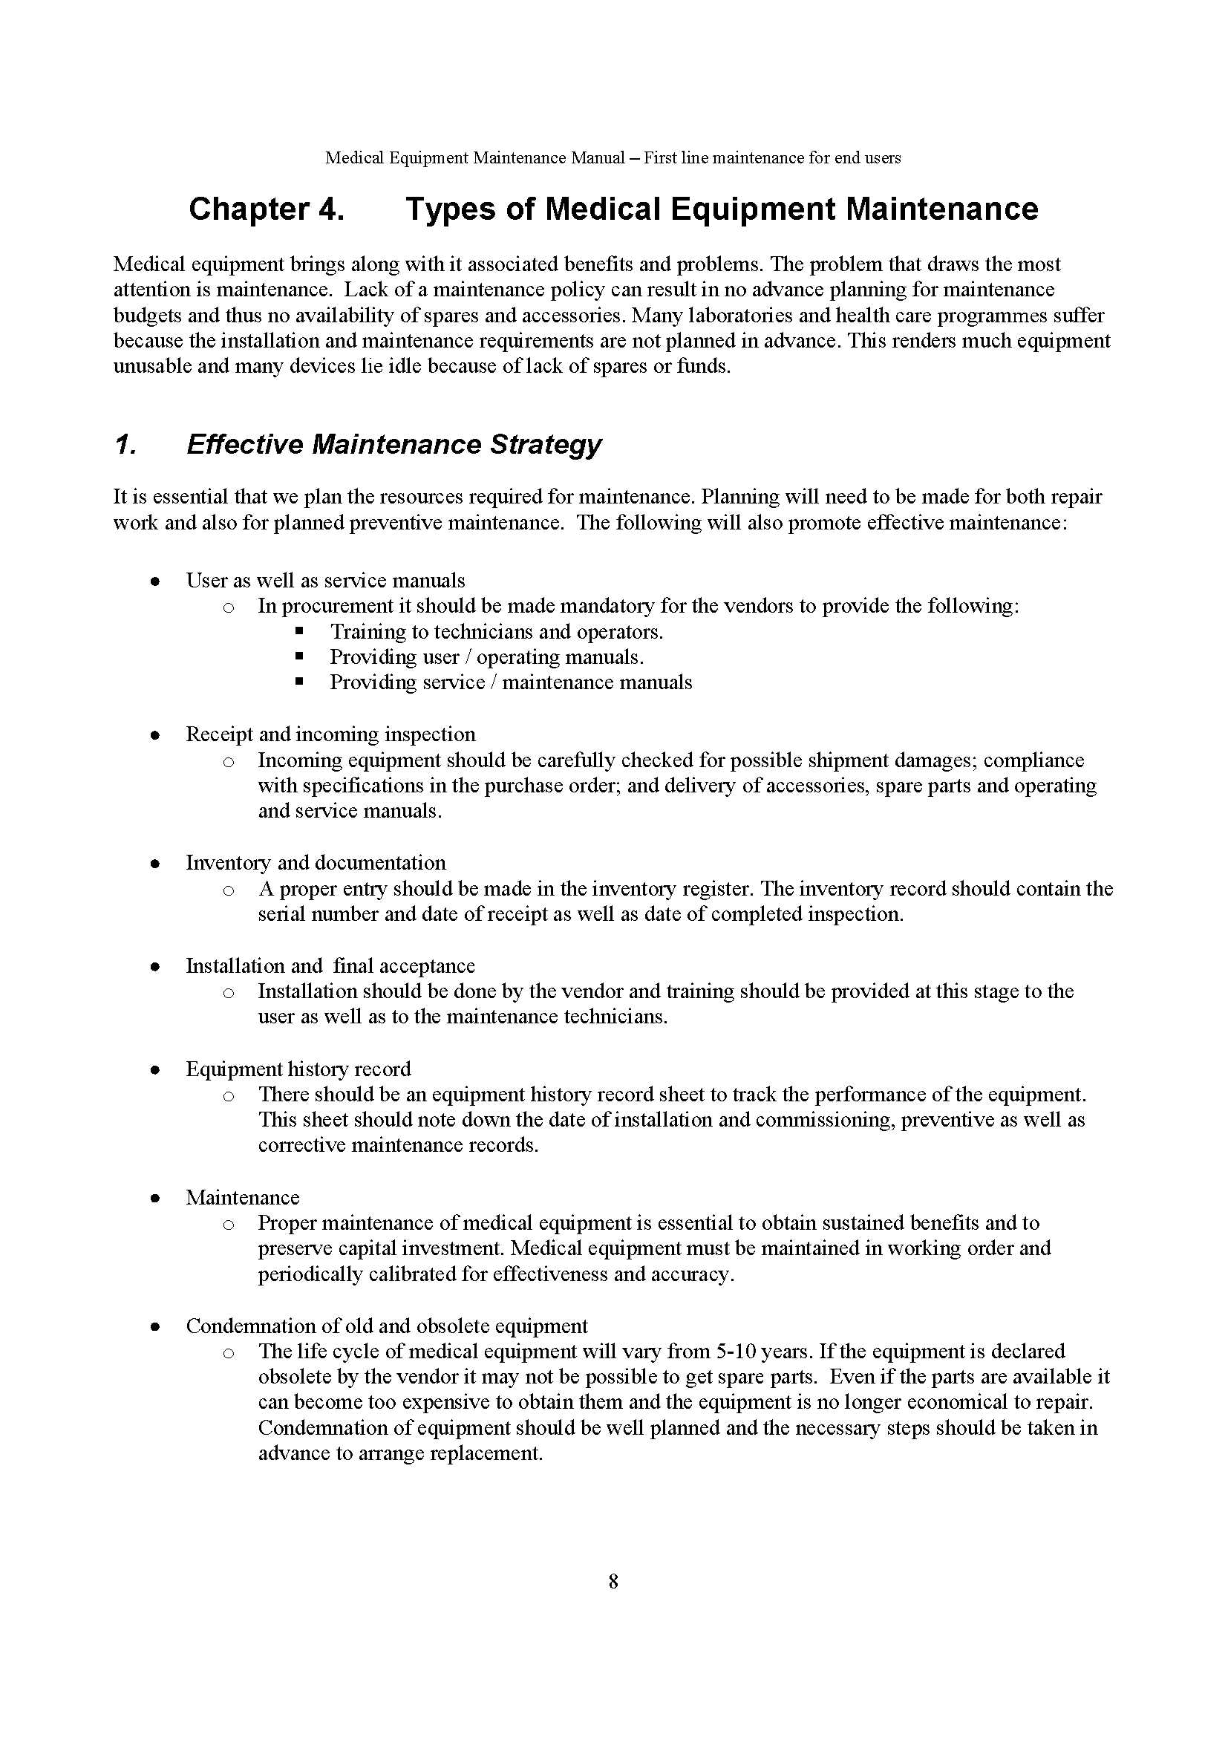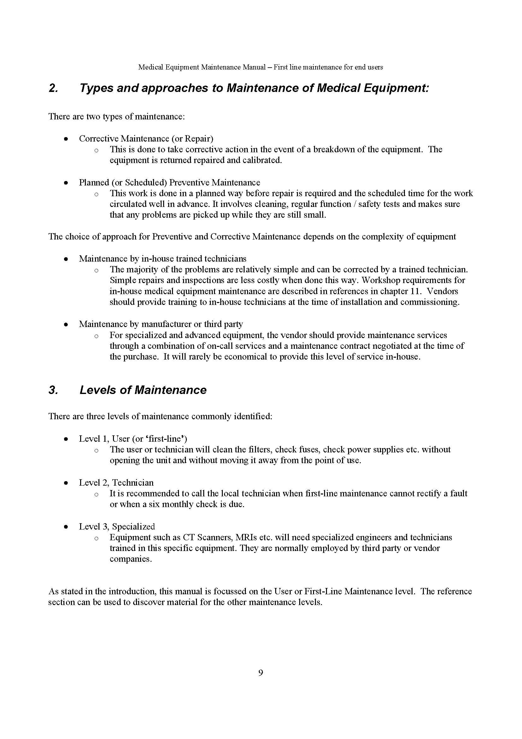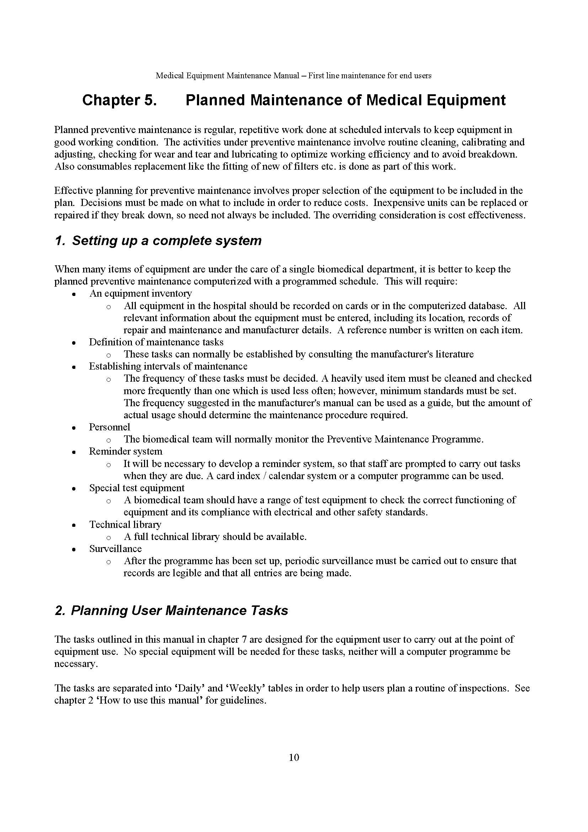Source: Ministry of Health and Family Welfare, New Delhi, October 2010

Sample Preventive Maintenance Checklist: Clinical Equipment

Question:
Do you have a maintenance checklist for each piece of medical equipment that outlines what should be done on a daily, weekly, semi-annual and/or annual basis in terms of: (1) cleaning, (2) visual checks and (3) function checks?

A Sample User Maintenance Checklist for Autoclaves/Sterilizers

Daily
Cleaning | - Remove any dust/dirt with damp cloth and dry off  - Remove water and waste matter from inside
Visual Checks | - Check all screws, connectors and parts are tightly fitted  - Check all moving parts move freely, all holes are unblocked
Function Checks | - Use troubleshooting guide if problems occur

Weekly
Cleaning | - Unplug, clean inside and outside with damp cloth and dry  - off
Visual Checks | - Check internal heating element connections are tight  - Replace heating element if covered with lime scale  - If plug, cable or socket are damaged, replace
Function Checks | - When next used, check pressure/temperature gauges rise  - When next used, check there are no leaks

Every Six Months
- Biomedical Technician check required

Source: This and page 19 are from: Medical Equipment Maintenance Manual, Ministry of Health and Family Welfare, New Delhi, India, October 2010

Sample Clinical Equipment Maintenance Information Sheet

Instructions: As you review the Sample Clinical Equipment Maintenance Information Sheet on the following page, please answer the questions below. Be prepared to discuss your answers with the group:

1. Do we have a schedule for clinical equipment maintenance?

2. Who is responsible for checking our clinical equipment?

3. Does that individual know what to look for and how to check the equipment to make sure it is in proper working order and accurately calibrated, if applicable?

4. Do we have a backup plan if equipment is out of order?

Sample Clinical Equipment Maintenance Information Sheet

Equipment Item | Location | Asset # or Serial # | Frequency of Service | Loan Equipment Available | Last Serviced | Sent | Returned | Next Due | Comments
Baby Scales |  |  | Annual | Yes
Centrifuge |  |  | Annual | Yes
Glucometer |  |  | Nil | No
Ultrasound Machine |  |  | Annual | Yes
Refrigerator-Drugs & Vaccines |  |  | Annual | Yes
Stethoscope |  |  | Annual | No
Patient Monitor-Vital Signs Monitor |  |  | Annual | No

Adapted from: Schedule for Clinical Equipment Maintenance, published by the Department of Health, Northern Territory Government, Canada
The Consequences of Equipment Breakdown

In some circumstances, practice owners may not see the need to budget for preventive maintenance. They may wait until a piece of equipment breaks down before they spend money on it.

Instructions: Working with your new small group, select a piece of equipment in a medical practice. Assume that it has broken down and draw on a flip chart a picture of the consequences to the practice if that equipment breaks down. Write the explanations of your picture in language that the owners will understand, such as lost time, increased cost, loss of customers, less profit, etc.

Building Self-Inspection

 | Instructions: Visualize your facility and imagine that you are walking through it:
General Conditions |  | Yes | No | N/A
- Are walking surfaces clean, clear of debris, and dry?
- Are stairs, steps, handrails, and landings in good condition?
- Is area lighting adequate?
- Is general housekeeping acceptable and storage neat and orderly?
- Is furniture in a good state of repair?
Building Evacuation and Life Safety |  | Yes | No | N/A
- Are exits properly identified and lighted?
- Are exit paths clear?
- Does the fire alarm work?
- Has the fire alarm been tested?
- Are evacuation floor plans posted?
- Are emergency phone numbers posted in conspicuous areas throughout the building?
Fire Prevention |  | Yes | No | N/A
- Are portable fire extinguishers available?
- Are extinguishers serviced/tagged annually?
- Are combustibles and trash controlled?
- Are flammables properly stored in cabinets?
- Is there any evidence of electrical equipment overheating?
- Are holiday decorations noncombustible?
- Has a licensed electrician inspected electrical wiring? Date inspected?
- Does wiring meet code requirements?
- Is there any evidence of electrical wiring overheating, blown fuses, tripped circuit breakers or worn insulation?
- Are multiple plug outlets and use of extension cords kept to a minimum?
Boilers and Heating Equipment |  | Yes | No | N/A
- Are boilers and water heaters serviced regularly?
- Are government inspection certificates on file and current?
- Is any water/steam/fuel leakage noted?
- Is there a preventive maintenance service contract in effect on heating/air conditioning equipment?
Outside Grounds |  | Yes | No | N/A
- Is the parking area well maintained?
- Are exterior walkways in good physical condition?
- Is exterior illumination adequate?
- Are all lights functional?
- Is signage adequate and properly secured?

Adapted from: Workplace Safety Toolkit, Nonprofitrisk Organization
http://www.nonprofitrisk.org/tools/workplace-safety/public-sector/foundation/selfinschk-ps.htm
Safe Behaviors Checklist

Instructions: Working independently, please assess your facility’s safety preparedness:
Yes No
- Employees are trained in safe procedures for all tasks associated with their job description. ___ ___

- Employees understand how to prevent accidents and injuries. ___ ___

- Safety procedures are part of all new employee orientation. ___ ___

- Unsafe behaviors are identified immediately and corrective actions are specified and enforced. ___ ___

- Employees know what Personal Protection Equipment (PPE) is necessary for their tasks, and that they are required to wear the relevant PPE. ___ ___

- Employees know how to maintain and store tools and other equipment. ___ ___

- Employees are trained in how to safely lift and transport heavy or bulky items. ___ ___

- Employees know how to handle money and other valuables in a way that does not invite theft or crime. ___ ___

- Employees are discouraged from remaining alone in the facility late into the evening. ___ ___

- Safety issues and expectations are clearly articulated in goals, objectives and performance expectations. ___ ___

Adapted from: Workplace Safety Toolkit, Nonprofitrisk Organization
http://www.nonprofitrisk.org/tools/workplace-safety/public-sector/foundation/selfinschk-ps.htm
Blood Borne Pathogens

Instructions: Fill in the blanks with the appropriate word from the list that follows: containers, contaminated, decontamination, equipment, exposure, immediately, infected items, personal protective, prevention, reporting, universal precautions, volunteers.

1. Blood borne pathogens can enter the skin from a needle stick, through a cut,
or by improperly handling _______________________.

2. Blood borne pathogens are a hazard for employees and ________________.

3. It is important to have an _______________________ plan.

4. The plan should include training, __________________, treatment and
___________________ procedures.

5. Training should cover how employees might be exposed, what ___________________________________equipment to wear,
how to dispose of this equipment and any ________________________,
how to identify biohazard waste containers, and what to do ________________ if they are _______________________.

6. Designated areas or _________________ should be provided for equipment storage, washing, ________________________ or disposal.

7. Staff members should be trained in and use _________________________.

Safety Hazards

Instructions: As you look over the list of possible safety hazards found in medical offices, underline any that are of concern in your own facility:

- Blocked emergency exits
- Paper towels in the open that collect bacteria
- Coffee pots and appliances left turned on
- Sharps and other infectious waste in regular trash cans
- Centrifuge, hazardous chemicals, and medications
in the employee lounge or patient areas
- Open desk or file drawers
- Electrical cords visible or snaked under rugs
- Sharps containers on floors
- Overloaded electrical outlets
- Electrical outlets accessible to children
- Clutter
- Children toys that are not cleaned regularly
- Un-mounted fire extinguisher
- Bars of soap rather than liquid soap
- Expired medications and solutions
- Recall items
- Glass capillary tubes
- Books and paper supplies stacked too close
to water-sprinkler heads
- Heavy objects on top shelves
- Sharps containers filled to full

Source: http://www.mypersonalhealthplan.org/Modules/ShowDocument2.aspx?documentid=1420

A Sample Monthly Safety Hazard Checklist

CLINIC

- Safety policy and procedure manual in place.
- Narcotics drawer is locked. Rx pads are secure.
- Medication is stored in a locked cabinet.
- Sink areas are in order.
- Temperature of refrigerator is 5 °C.
- No employee food items in the refrigerator.
- Sharps disposal containers are off the floor, secure, and not overflowing.
- Chart in holder is out of patients’ or visitors’ view.
- All electrical cords are grounded and not exposed.
- Crash cart is available and checked.
- Floors are clean and dry.
- Bathrooms have soap, paper towels, and toilet tissue.
- All sinks have hot water with temperatures not hotter than 26 °C.
- Laundry bags are tied and stowed in laundry hamper.
- Garbage bags are not overflowing and are changed daily or as needed.
- Hazardous waste disposable containers are not accessible to patients or children.

PROCEDURE AND CLEAN-UP ROOMS

- Floors are clean and dry.
- Emergency light works.
- Sterilization processes are in place.
- Person washing instruments uses universal precautions.
- All boxes are off floors.
- Goggles and gloves are available.

GENERAL

- Fire exits are accessible.
- Exit signs have working lights.
- Fire alarms are working.
- Fire extinguishers are secured on wall.
- Fire doors are closed.
- Hallway is free of equipment or boxes.
- Ceiling lights are in working order.
- Fire drills are routinely held.

GROUNDS

- Walkways and driveways are clear of debris.
- Hedges and bushes aren’t overgrown blocking walkways or view.
- Drains function properly and are free of debris.
- Designated smoking area is clean.
- Tree branches do not interfere with power lines.
- Trash is placed in dumpster and doors are closed.
- Lawn is trimmed and maintained.
- Lighted signs and exterior lights function properly.
- Walkways and driveways are intact and free of potholes.

Source: http://www.mypersonalhealthplan.org/Modules/ShowDocument2.aspx?documentid=1420

Security Procedures

The safety, security and protection of patients, staff, sensitive medical records, drugs and other tangible assets are your responsibility.

Instructions: Please discuss the answers to the questions below with the larger group.

1. What are your major security issues?

2. What security measures have you taken?

3. What type of security training do you provide to your staff?

Possible Security Measures

Physical security measures can include the following:
- Some form of after-hours locking, with staff relying on conventional access;
- Control of perimeter doors or internal approaches to certain areas;
- Physical barriers and containers (such as walls, doors, counters, windows, ceilings, filling cabinets, safes, vaults, etc.);
- Surveillance, detection, response and recording, through human measures (security officers and/or through electronic security systems (alarms, closed circuit television, etc.);

- Physical access controls (such as security officers, photo ID, controlled door/gates/turnstiles, and electronic access control, etc);

- Security operations (human functions) including surveillance, monitoring, presence and response to both security risks and general facility and management operations.

Waste Management

Storage facility grounds, including the area around healthcare facilities, must remain free of health care waste and other garbage. Maintaining a clean environment where pharmaceuticals and other health supplies are stored will reduce the number of pests—insects and rodents—and reduce the number of people, including children, who may be injured by used medical equipment or discarded medicines.

Check with local officials about laws that pertain to health care waste management and environmental protection before instituting a disposal technique.

Plan storage, transportation, and disposal techniques that are practical and simple. Monitor disposal practices on a regular, frequent basis.

Different types of waste that must be destroyed safely and effectively and their methods of disposal include:

Non-Medical Waste

1. Garden rubbish: Compost leaves, sticks, weeds, and trimmings
from shrubs and trees, if feasible. Designate a separate area for composting.

2. Cardboard cartons: If possible, recycle cardboard; otherwise,
treat like ordinary rubbish.

3. Ordinary rubbish: Where municipal solid waste facilities exist, dispose of ordinary rubbish in the municipal dump. Otherwise, burn or bury it.

4. Human waste: Use pit latrines or other toileting facilities to dispose of all human waste.

Health Care Waste

1. Sharps waste: Single-use disposable needles, needles from auto-disable syringes, scalpel blades, disposable trocars, sharp instruments requiring disposal, and sharps waste from laboratory procedures.

2. Other hazardous medical waste: Waste contaminated with blood, body fluids, human tissue; compounds such as mercury; pressurized containers; and wastes with high heavy metal content.

3. Pharmaceuticals: Expired, damaged, or otherwise unusable medicines and
items contaminated by or containing medicinal substances.

Instructions: Please discuss your answers to the questions below.
- Do you emphasize safe waste management procedures? If so, how?

- What are your procedures for disposing of sharps waste, other hazardous medical waste and pharmaceuticals?

- Do you monitor your waste disposal practices on a regular and frequent basis? If so, what is your procedure?

Adapted from: John Snow, Inc./DELIVER in collaboration with the World Health Organization.
Guidelines for the Storage of Essential Medicines and Other Health Commodities.
2003. Arlington, Va.: John Snow, Inc./DELIVER, for the U.S. Agency for International Development

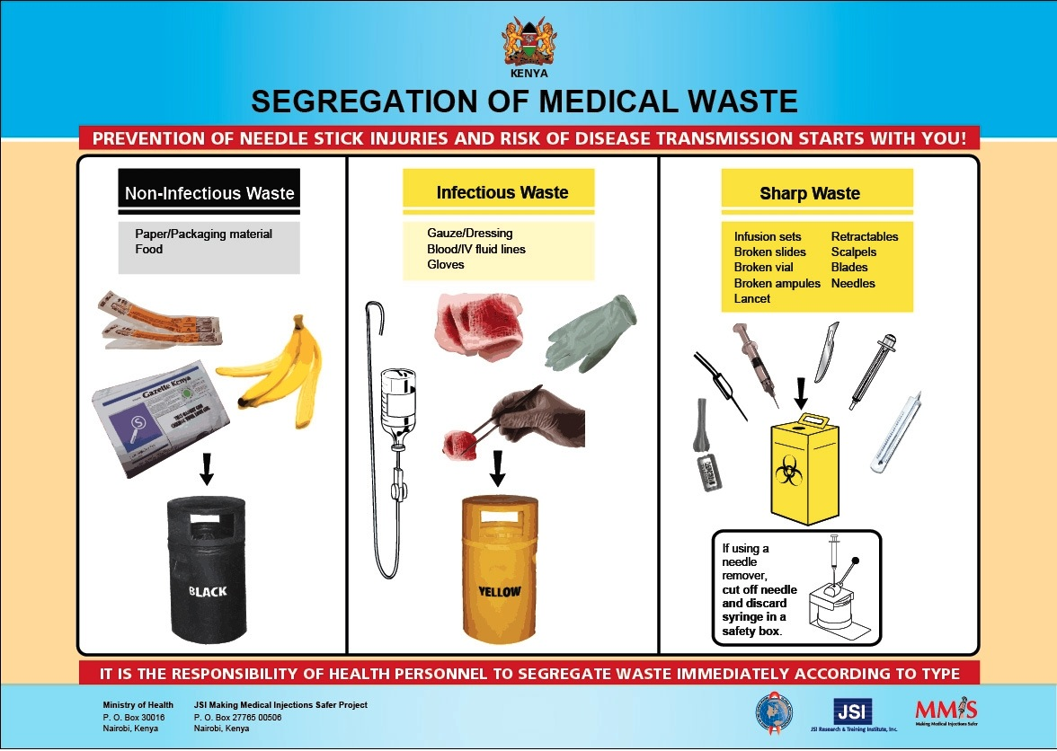

Case: Northlands Health Center

Directions: Working with your table group, please review the case information below and answer the question that follows it.
NORTHLANDS HEALTH CENTER (NHC)

Northlands Health Center (NHC) is a private hospital owned by Dr. Viraj Shah, an entrepreneur who has made a name both as a medical philanthropist and as an accomplished chiropractor. He established this practice several years ago when he came back to Kenya, after completing his studies at the University of Bombay, India. NHC is located in Nairobi’s Upper Hill area along Mara Road and boasts of offering superior medical services in comparison to its competitors. The practice has five departments, namely: Medical, Dental, Physiotherapy, Laboratory and Imaging. It employs two general medical practitioners, one dentist, one physiotherapist, two laboratory technologists, two nurses and three support staff.

Following the transition from central to county governments in Kenya, the county government of Nairobi is in the process of conducting a comprehensive audit of all the health facilities within the county, with the aim of recertifying them as health service providers. This audit involves inspection of the physical facilities and a review of policies and procedures in place, together with compliance with statutory requirements. NHC is due for this audit mid next month.

To ensure that any issues are addressed upfront, Dr. Viraj Shah developed a checklist that he used last week to personally conduct the facilities audit. He started off with the inspection of the building and equipment. He noted that the corridors leading to the doctor’s rooms were dimly lit following the failure of two bulbs located on either end of the corridor. One nurse informed him that the bulbs failed about three weeks ago and the failure was brought to the attention of the hospital administrator, but no replacement has been made. The nurse further informed him that, following the bulb failure, one patient, while walking in the dark to the doctor’s room, knocked into a flowerpot and sustained a bruise on her right leg. The nurses had to worked to calm down the angry patient after attending to her bruise. The patient could easily have sued the hospital!

At the hospital reception, the ceiling board made from chipboard was flaking off, with most of it hanging loose. The hospital administrator blamed this on bats that hide in the roof, whose urine and feces “burn” and discolor the ceiling board paper. The bats’ menace has also left an awful smell at the hospital reception.

At the laboratory, Dr. Viraj Shah found a machine technician at work. The technician was repairing a machine that had broken down following a drop in electricity voltage. This was the fourth time the technician had been called in to repair the machine this month. This constant break down in equipment has made it difficult for the laboratory to break-even in its operations.

While testing the flow of water in the laboratory sinks, Dr. Viraj Shah noticed that the drainage was blocked. The reasons given for this blockage were that there were no solid separators or traps in the laboratory sinks. In addition, attempts to unblock the sinks had revealed that staff had not been exercising due caution when disposing of solid waste, such as cotton and surgical gauze, down the sinks.

The hospital had recently acquired two expensive state-of-the-art microscopes for laboratory use. However, Dr. Viraj Shah’s inspection revealed that these were missing from the lab. They were said to have been stolen the previous month. The administrator had been quietly investigating their whereabouts, without success. In the meantime, he was hiring the microscopes from a nearby laboratory on an as-needed basis. This, of course, has increased laboratory operating costs.

Dr. Viraj Shah then crossed over to the Dental and Imaging department. Here, he found staff idle and chatting. They had canceled all appointments for the day following the frequent equipment downtime experienced earlier in the week. The department administrator was tired of hiring emergency biomedical engineers at short notice. They were costing the hospital a lot of money. So he had decided to temporarily stop the operations of this department while he considered the best way to contain the downtime. The staff believe that the frequent downtime could be the result of manufacturer defects.

The washrooms were terrible! The cistern covers were broken, with no water getting in. The smell was overpowering and Dr. Viraj Shah could not imagine the last time the toilets had been cleaned. There were big cockroaches on the floor. He was terrified and screamed when a large rat jumped from the cistern right at him. This was the ultimate act of neglect. Apparently, the contract with the cleaning services company had expired last month. The department administrator was waiting to hire another company, whose manager had promised to reciprocate by giving a percentage of the contract sum to the administrator. Dr. Viraj Shah was very upset when he left that department.

In the Medical department, staff were very pleased to receive Dr. Viraj Shah. The last time he had been seen here was about six months ago. The visit occurred when he was commissioning free medical check-ups for people over 80 years old. He noticed that most chairs in the patient waiting room had been worn out, with the covers torn. The nurse here explained that, given the condition of the chairs, the patients preferred to stand while waiting to see the doctor. This was absurd but it was the reality. The administrator explained that the chairs were just acquired six months ago and could not possibly be replaced so soon. The practice had been to replace furniture after every two years. All of the magazines in the waiting room sports magazines that were three years old. There was no daily newspaper or television set available in the waiting room. Unhappy with these conditions, most of the patients visit the hospital only once and then never return.

In the doctor’s room, he found Dr. Juma Ngao on duty. The room did not have any natural light as there was no window. The electrical fuse supplying this room with electricity had blown out the previous evening. Dr. Juma Ngao was using a spot light to light the room and to enable him to examine patients. Dr. Viraj Shah noticed that the doctor’s table was covered with a torn brown tablecloth. Dr. Juma Ngao explained to him that its original color was white, but it had not been washed for years.

Dr. Viraj Shah concluded his inspection of the facility with a note that both the internal and external painting of the building had faded and was peeling off. He realizes that he has a long list of things to do to ensure that the hospital passes the upcoming Nairobi County Public Health Inspection. He is contemplating using his influence to talk to the county governor to allow him two months before sending out inspectors.

Question: What facility maintenance and management actions should Dr. Viraj Shah take in order to improve the financial well-being of the hospital and to ensure that NHC is recertified? Please address the following areas of concern:

Housekeeping:

Building and Equipment Maintenance:

Safety and Security:

Waste Management:

Administration:

Financial Management:

Clinical Management:

The Next Step

Instructions: We have discussed your responsibilities for facility cleanliness, maintenance, safety, security and waste management. We have provided a number of checklists to help you monitor and improve these areas. Now you need to:

- discuss facility cleanliness standards with all your staff and give them the training and resources necessary to meet those standards;
- walk through your building and complete the self-inspection
checklist, taking action to address
any issues; and

- conduct a monthly safety hazard audit.

My Key Takeaway

Instructions: Please stand up when you have completed this sentence:

My key takeaway from this session is:
Evaluation Sheet

Instructions: Please answer the questions below as completely and constructively as possible. Thank you!

Strongly Neither Strongly
Agree Agree nor Disagree
This training: Disagree
covered the content as advertised 5 4 3 2 1
was logical and effective 5 4 3 2 1
provided information I can apply in my work 5 4 3 2 1 included useful handouts for future reference 5 4 3 2 1

The facilitator:
was knowledgeable 5 4 3 2 1
was effective 5 4 3 2 1
stayed on topic and on time 5 4 3 2 1

As a result of this workshop, I am better able to:
discuss what my facility can do to have a positive
first impression on our patients and visitors; 5 4 3 2 1
identify four areas of concern in facility management; 5 4 3 2 1
rate the cleanliness of my facility; 5 4 3 2 1
explain basic clinical equipment maintenance
procedures; 5 4 3 2 1
review a building maintenance checklist; 5 4 3 2 1
discuss facility safety issues and procedures; 5 4 3 2 1
explain our security measures; 5 4 3 2 1
share waste management methods; 5 4 3 2 1
propose how to handle issues related to facility
management. 5 4 3 2 1

Excellent Average Poor
Overall, I would rate this training: 5 4 3 2 1

I would recommend this training to a colleague: ___ Yes ___ No

Personal Significance of Workshop:

Of the ideas or techniques covered, I think that these will be of most use to me:

Recommendations for Improving the Training:

Additional Comments:

DISCLAIMER
The author’s views expressed in this publication do not necessarily reflect the views of the United States Agency for International Development or the United States government.

